**RASMUS**

**Electrical Vehicle Charging Solution**

**Delta EV Charger Back Office  
System**

User Manual

**Document Version History**

|  |  |  |  |
| --- | --- | --- | --- |
| **Version** | **Date** | **Author** | **Summary of changes** |
| 0.1 | May 24, 2016 | Jingjong Chen | Draft version for real charger connection |
| 0.2 | Sep 06,2016 | Dandan.Cao | User guide |
| 0.3 | Sep 29, 2016 | Jingjong Chen | Refine some description |
| 0.4 | Oct 28,2016 | Cuiping.Yan | Update User guide |

Contents

1 Login 6

1.1 Login SMS 6

1.2 Forget password 6

1.3 Change language 6

2 Admin 7

2.1 User Management 7

2.1.1 Add user information 7

2.1.2 Edit user information 7

2.1.3 Delete user information 7

2.2 Network Configuration 8

2.2.1 Add one Network 8

2.2.2 Edit Network 8

2.2.3 Enable or disable Network 8

2.3 Connector Type 8

2.3.1 Add Connector Type 8

2.3.2 Edit Connector Type 8

2.3.3 Enable or disable Connector Type 8

2.4 Charger Type 9

2.4.1 Add Charger Type 9

2.4.2 Edit Charger Type 9

2.4.3 Enable or disable Charger Type 9

2.5 Network-User 9

2.6 Land Owner-Location 9

3 Network 10

3.1 Overview 10

3.2 Location 10

3.2.1 Create one Location 10

3.2.2 Delete one Location 10

3.3 Authorization list 11

3.3.1 Add Authorization IDs 11

3.3.2 Create Authorization list 11

3.3.3 Add Subscribed Charger 11

3.4 Statistic 11

3.5 Firmware 12

3.5.1 Add Firmware 12

3.5.2 Edit FTP 12

3.5.3 Delete Firmware 12

3.5.4 Distribute Firmware 13

3.6 Notifications 13

4 Location 14

4.1 Overview 14

4.2 EV Chargers 14

4.2.1 Create one Charger 14

4.2.2 Delete Charger 15

4.3 Notifications 15

5 Charger 16

5.1 Overview 16

5.2 Action 16

5.3 Notification 17

5.4 Event 17

5.5 Charging Sessions 17

5.6 Configuration 17

5.7 Authorization lists 17

5.8 Statistic 17

5.9 Connect to the Charger 18

# Login

## Login SMS

1. Please contact administrator to ask for an account with “Admin” authority.
2. Please enter <http://172.22.35.131:7001/EMEA/login.html>
3. Input user name and password.

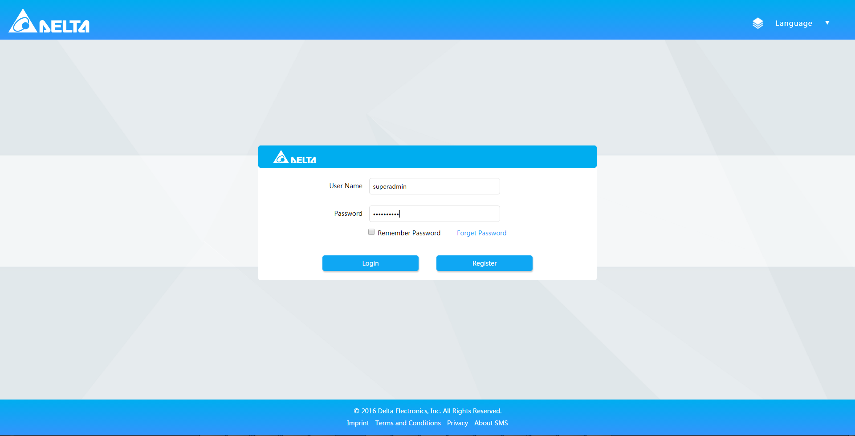

1. Click Login.

*NOTE: if you already have an account, network, and know which location to add charger, please skip it.*

## Forget password

1. Please enter url <http://172.22.35.131:7001/EMEA/login.html>
2. Find “Forget password” and enter your email address.

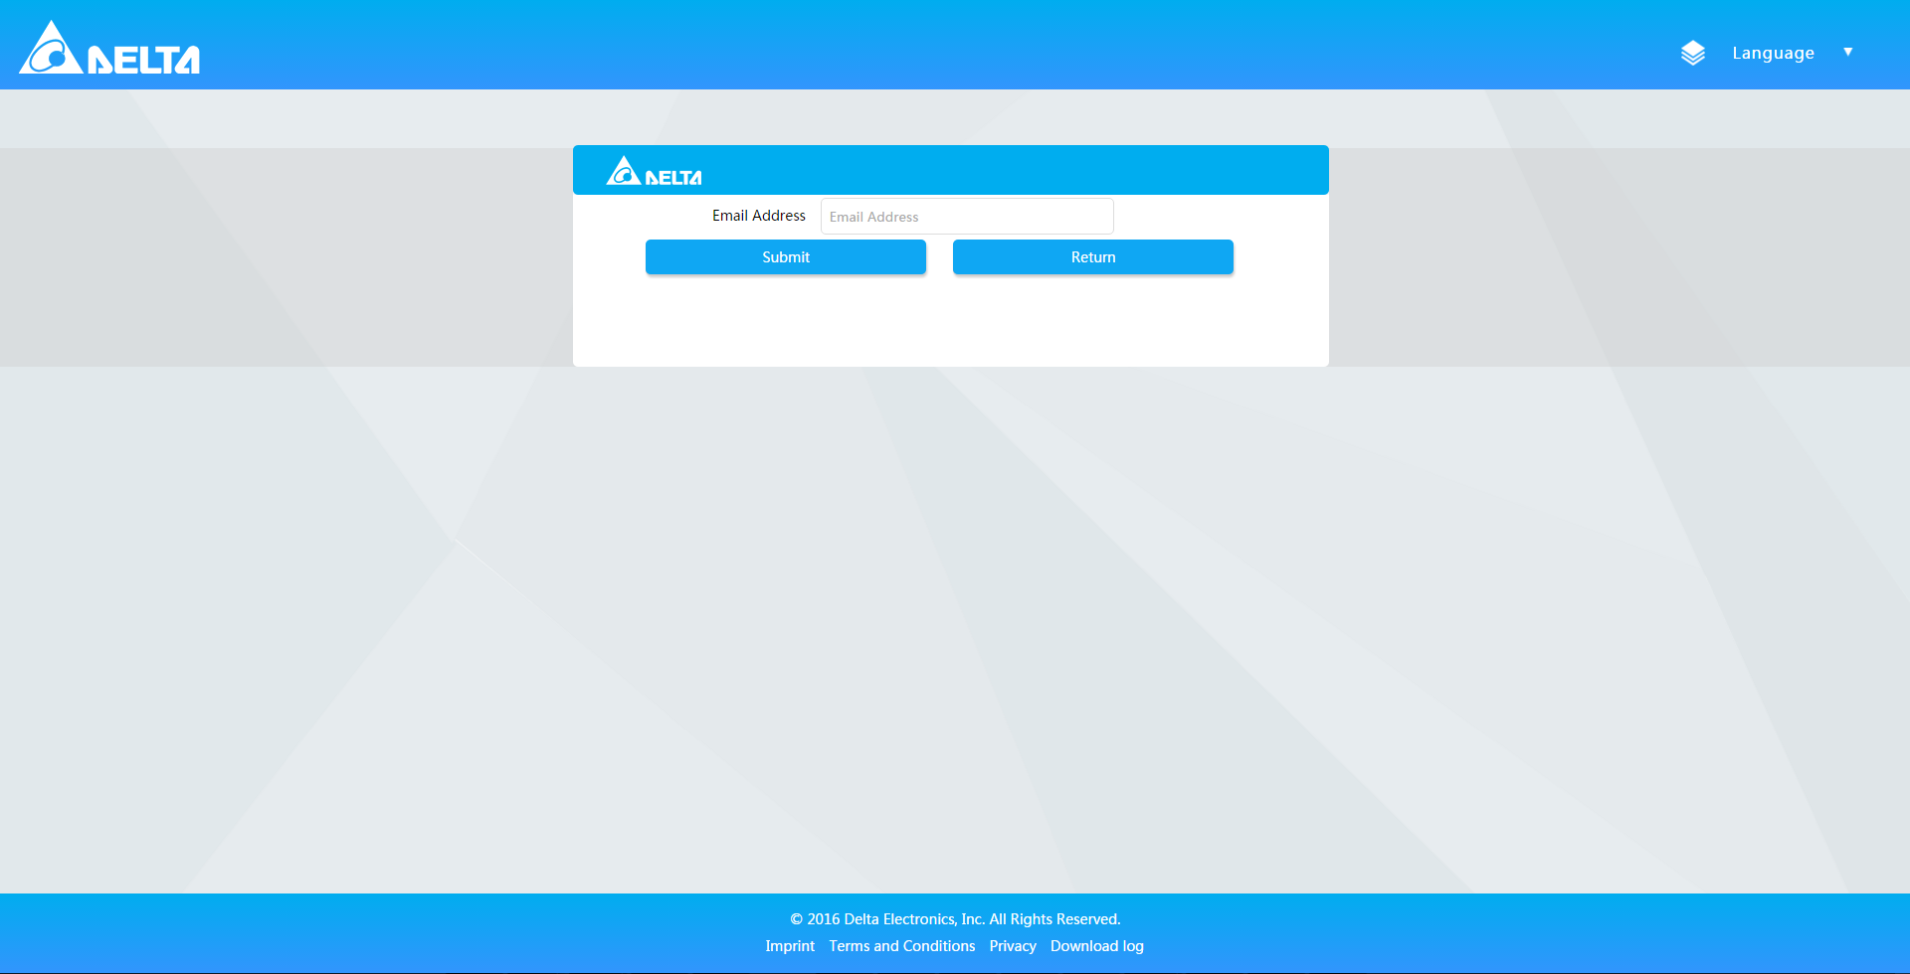

1. Look for password in the corresponding mailbox.

## Change language

1. Go to any page.
2. Click “Language” in the header.
3. Select any item in the drop-down menu.

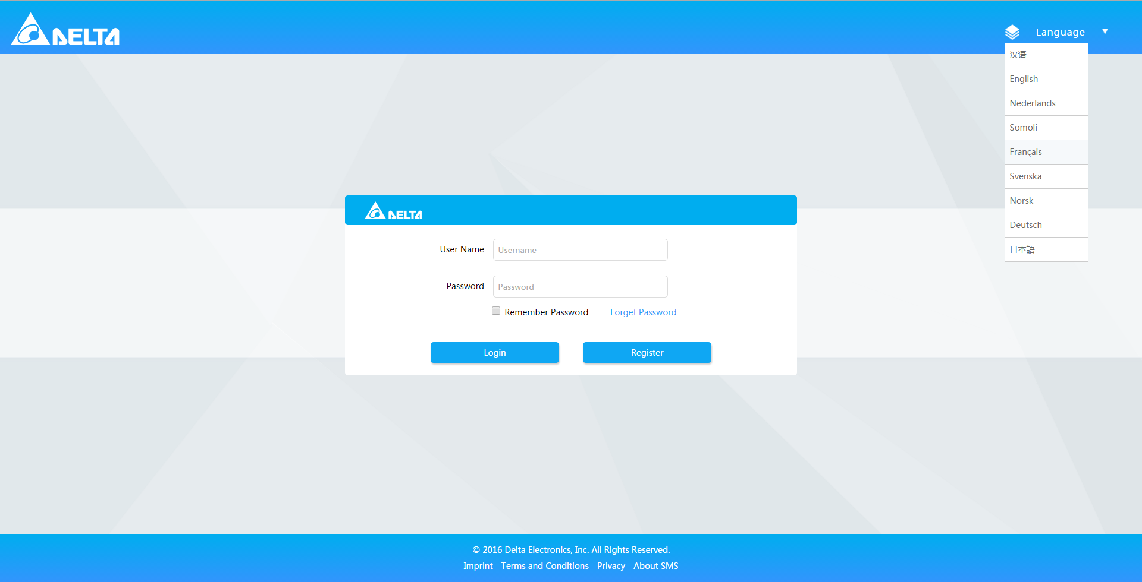

# Admin

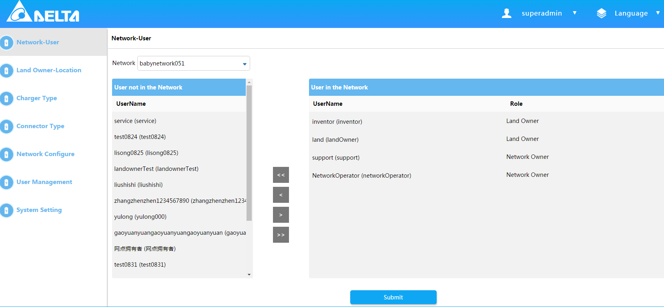

## User Management

### Add user information

1. Login SMS system.
2. Move over the user name in the header.
3. Select “Admin” in the drop-down menu.
4. Select “User Management” tab in the left menu.
5. Click “Add User” button.

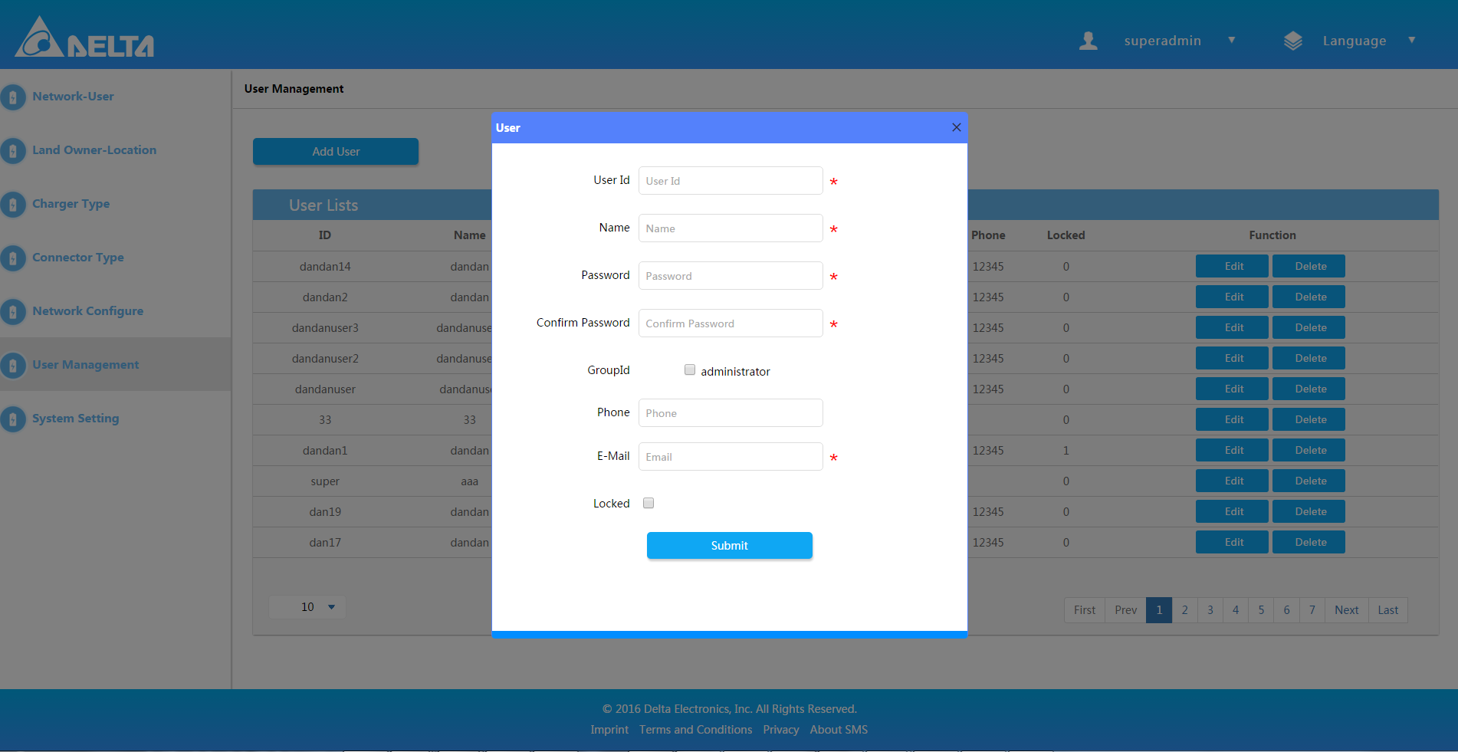

1. Input some information.
2. Click “Submit” button to save it.

### Edit user information

1. Login SMS system.
2. Move over the user name in the header.
3. Select “Admin” in the drop-down menu.
4. Select “User Management” tab in the left menu.
5. Click “Edit” to update the user information.

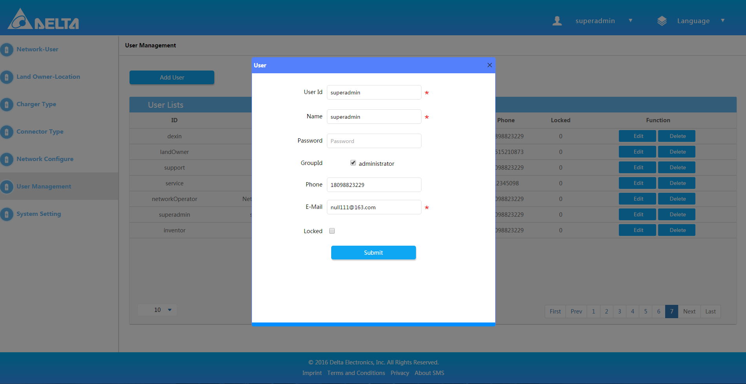

### Delete user information

1. Login SMS system.
2. Move over the user name in the header.
3. Select “Admin” in the drop-down menu.
4. Select “User Management” tab in the left menu.
5. Click “Delete” to delete the user information.

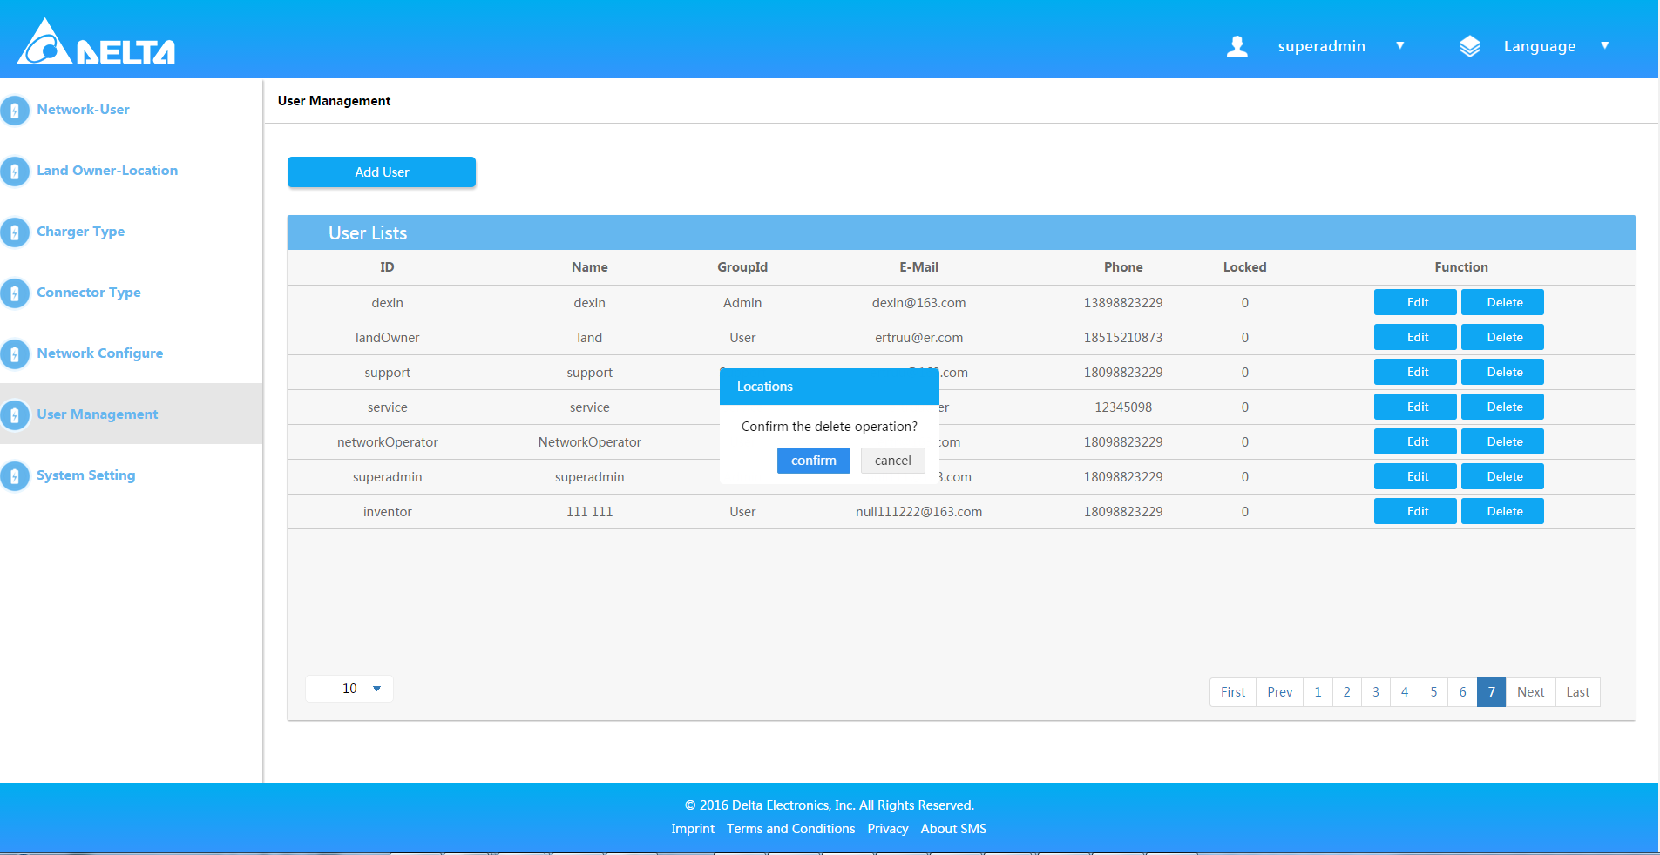

## Network Configuration

### Add one Network

1. Navigate to Admin page, there is the option “Network Configure” on the left list.
2. Click “Add Network” button, then there will be a popup window.

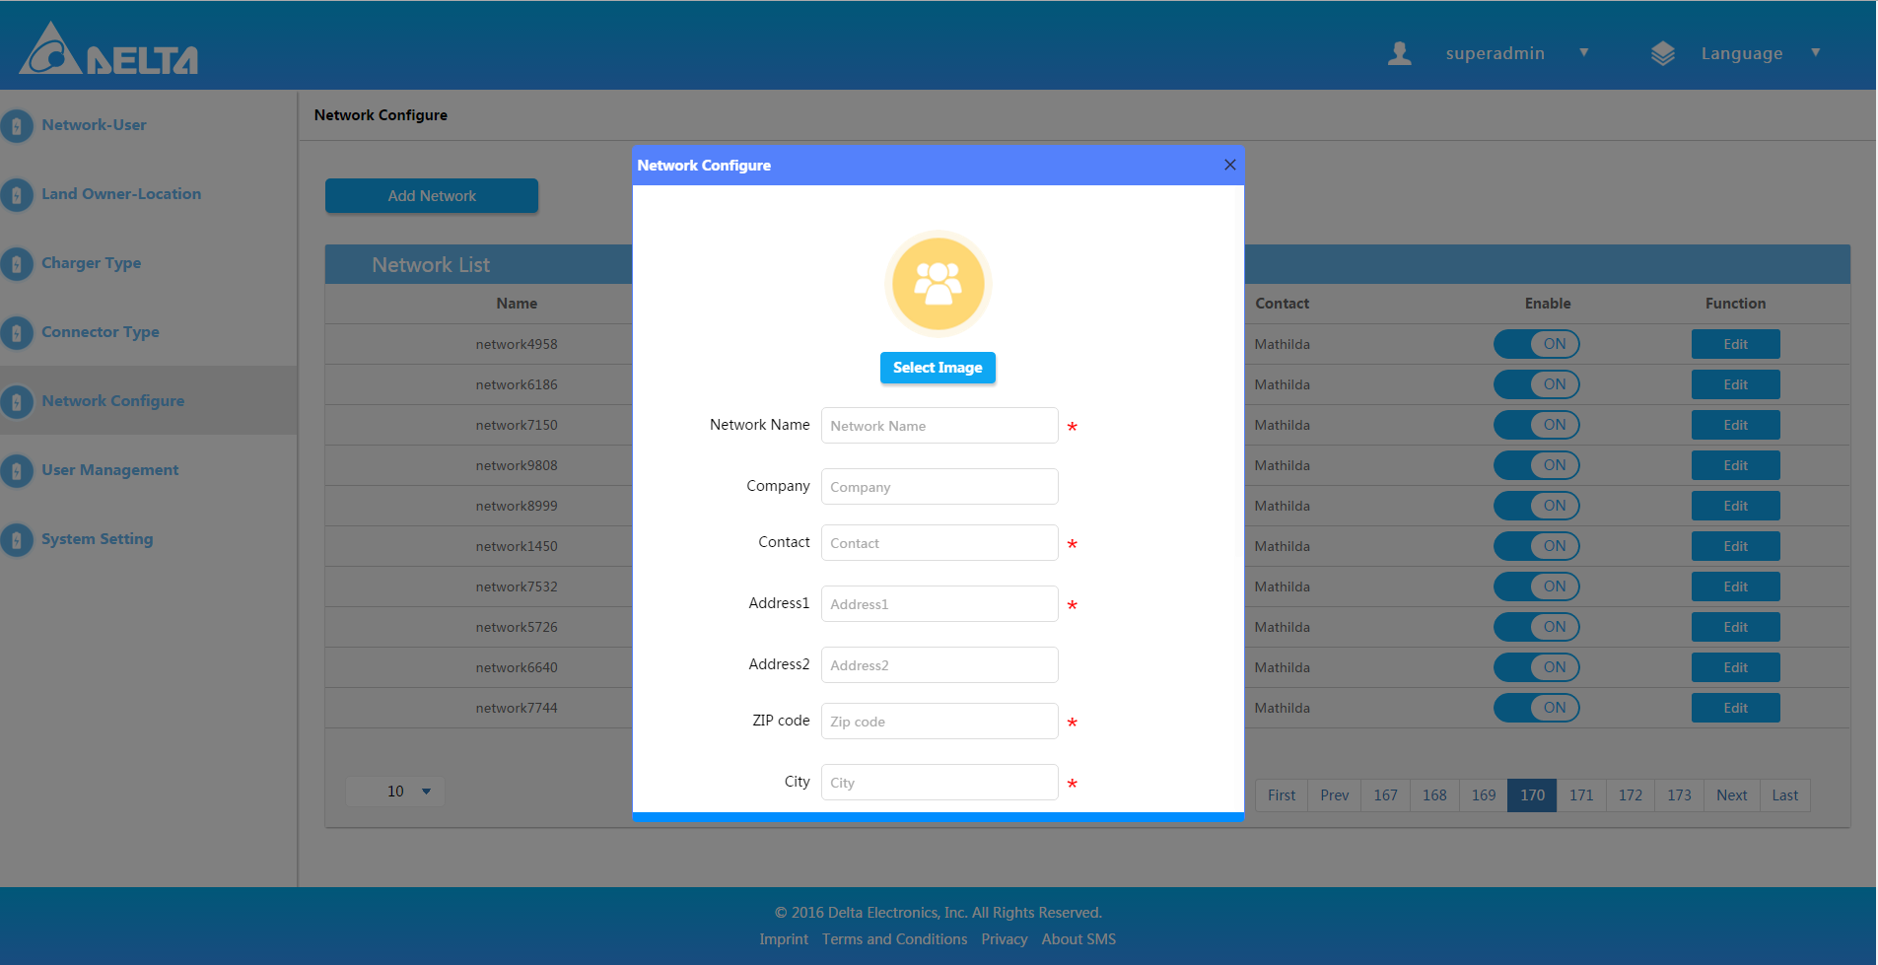

1. Fill up necessary information and click “Submit” to save.

### Edit Network

1. Navigate to Admin page, there is the option “Network Configure” on the left list.
2. Click “Edit” button to edit the network.

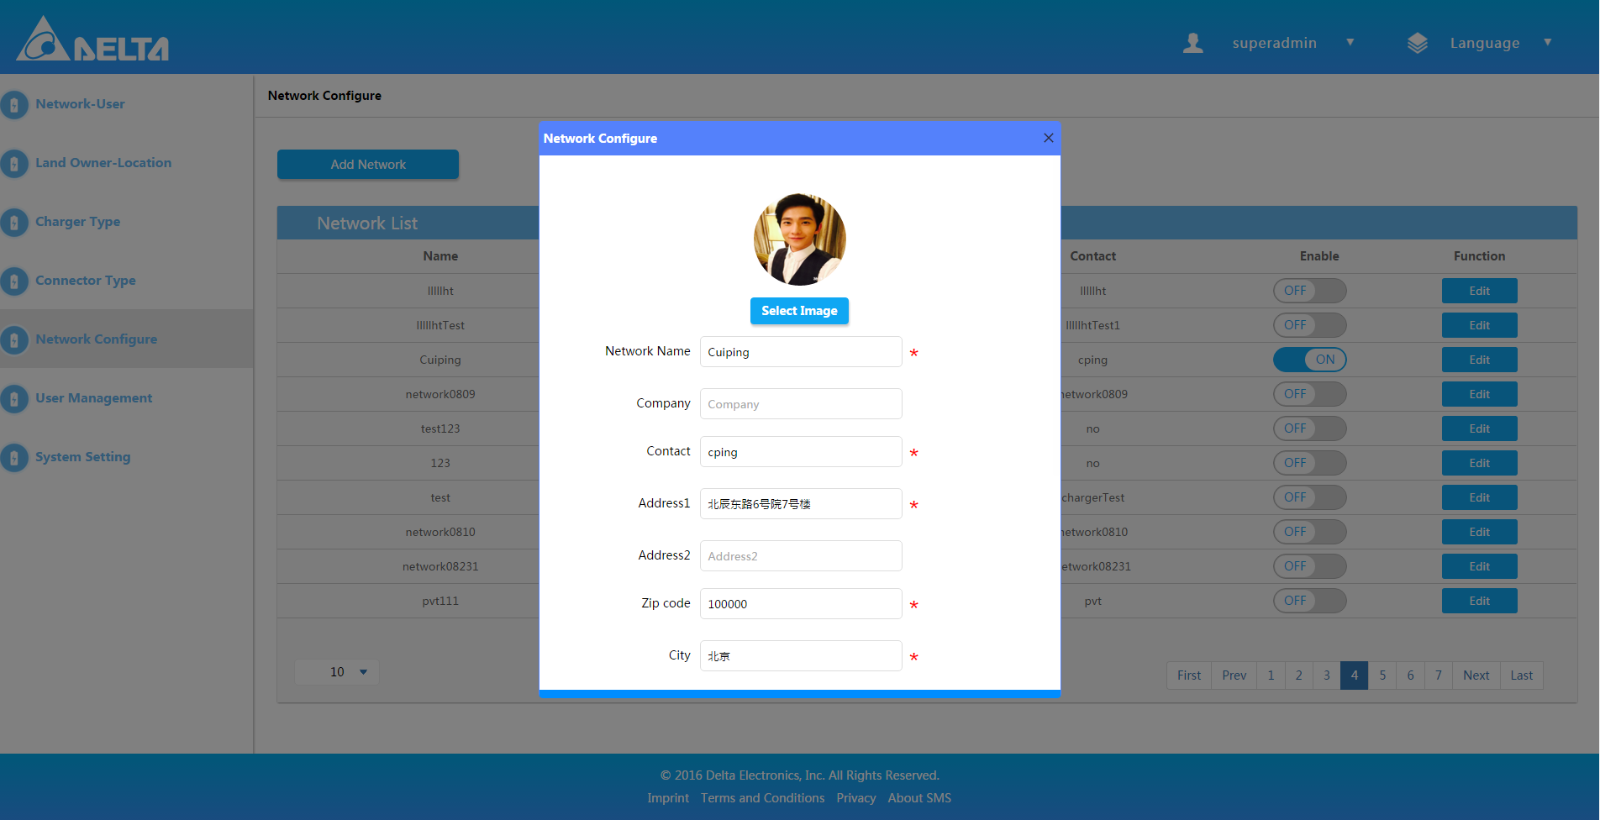

### Enable or disable Network

1. Navigate to Admin page, there is the option “Network Configure” on the left list.
2. Click switch button to enable or disable the network.

## Connector Type

### Add Connector Type

1. Navigate to Admin page, there is the option “Connector Type” on the left list.
2. Click “Add Connector Type” button, then there will be a popup window.

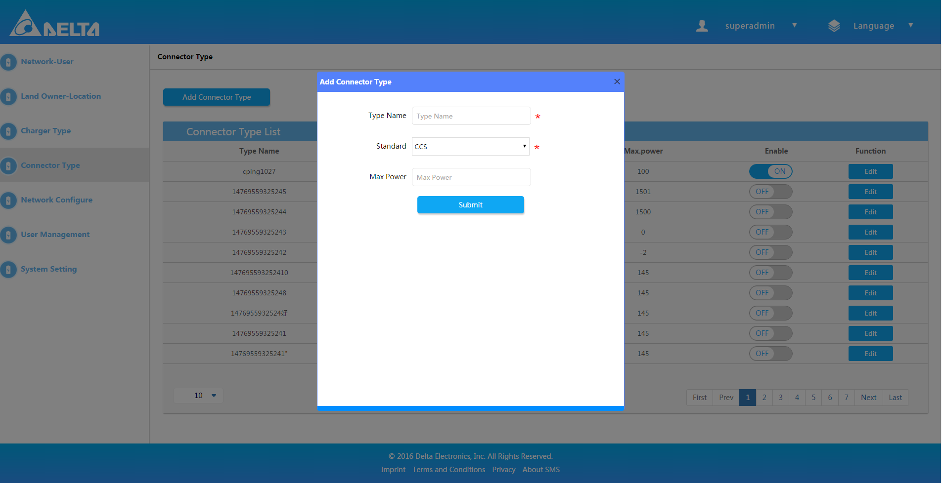

1. Fill up necessary information.
2. Click “Submit” to save.

### Edit Connector Type

1. Navigate to Admin page, there is the option “Connector Type” on the left list.
2. Click “Edit” button to edit it.

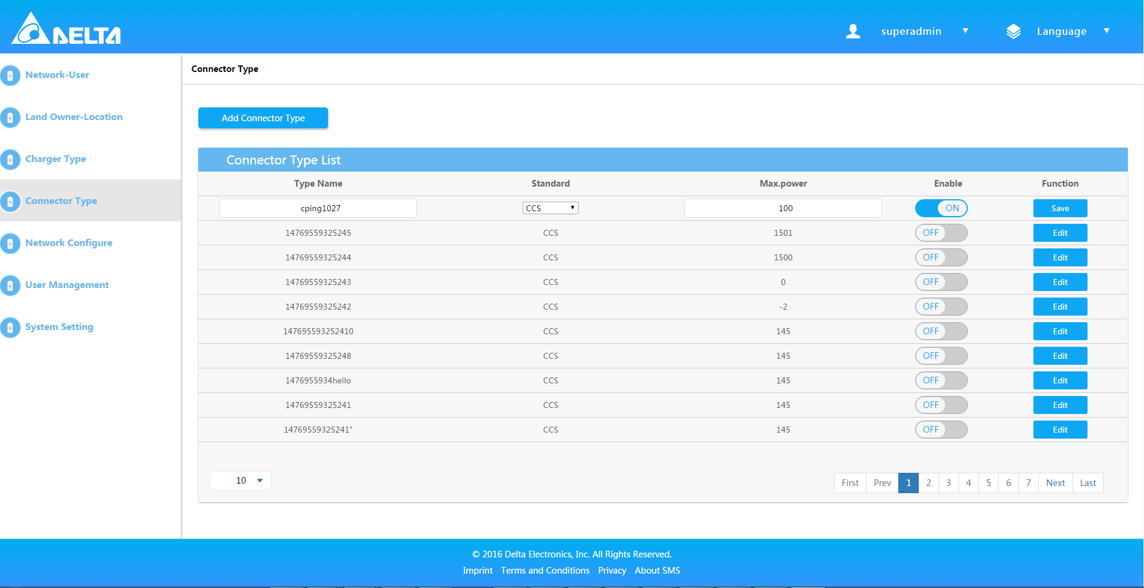

### Enable or disable Connector Type

1. Navigate to Admin page, there is the option “Connector Type” on the left list.
2. Click the switch button to enable or disable it.

## Charger Type

### Add Charger Type

1. Navigate to Admin page, there is the option “Charger Type” on the left list.
2. Click “Add Charger Type” button, then there will be a popup window.

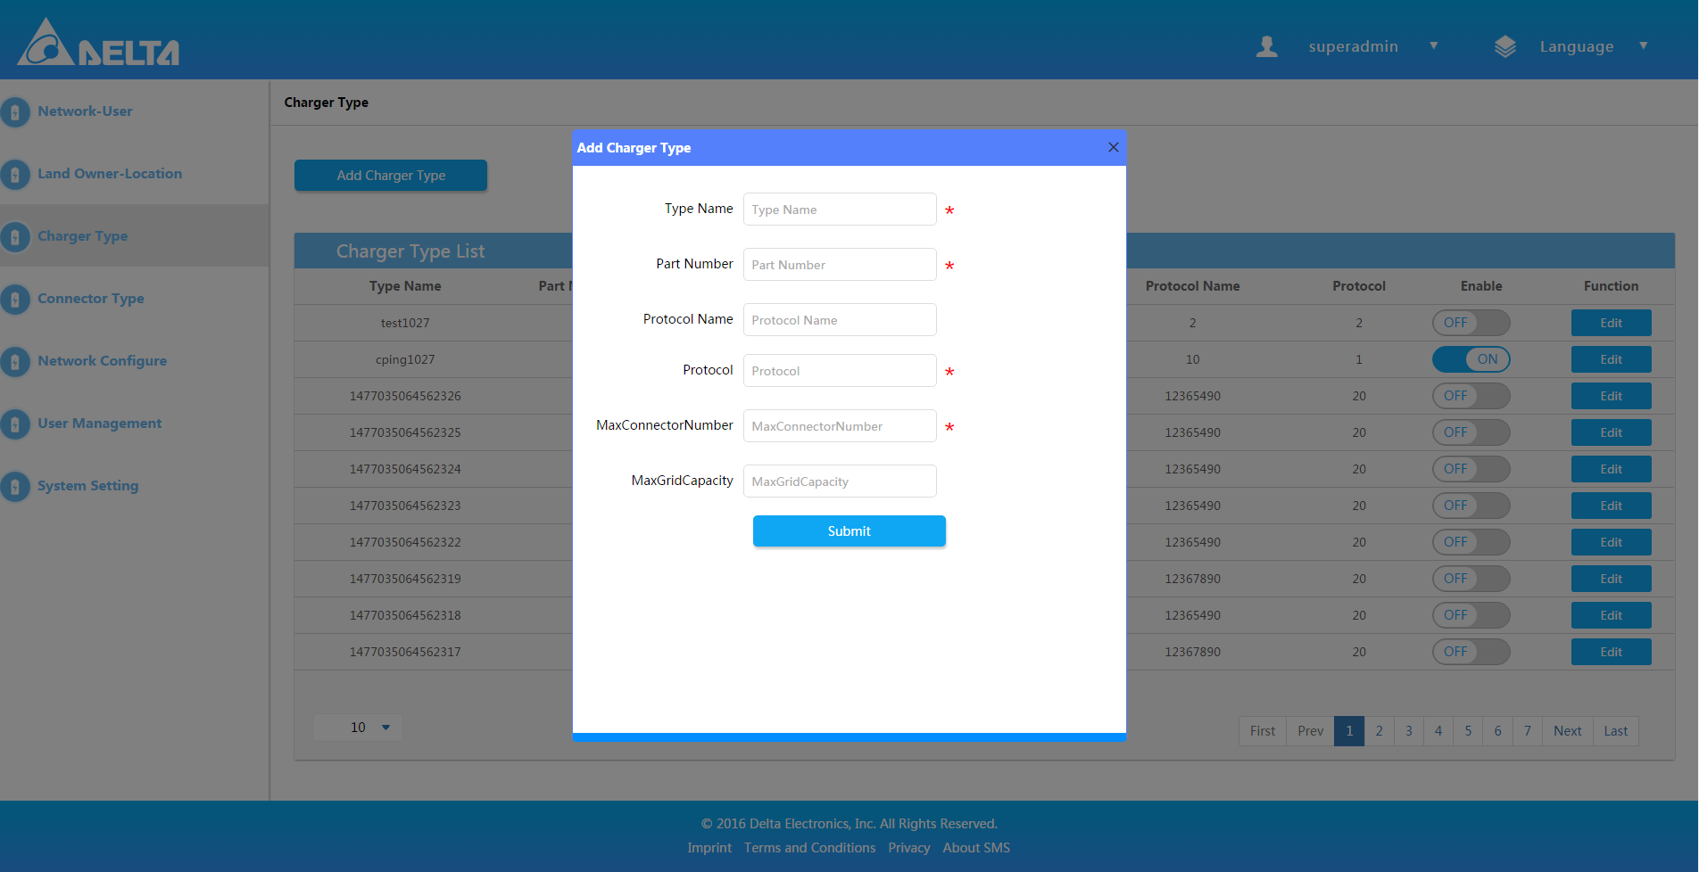

1. Fill up necessary information and click “Submit” to save.

### Edit Charger Type

1. Navigate to Admin page, there is the option “Charger Type” on the left list.
2. Can click “Edit” button to edit it.

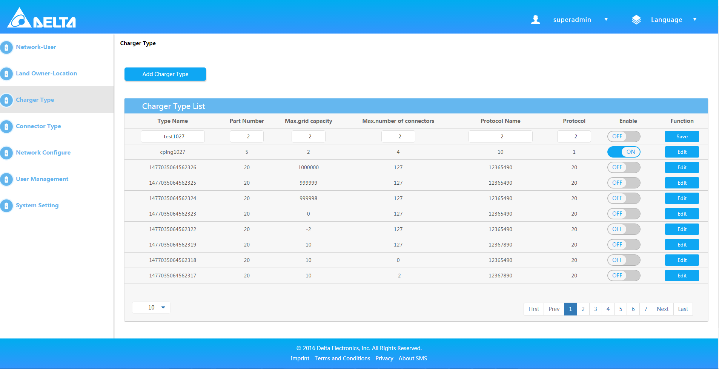

### Enable or disable Charger Type

1. Navigate to Admin page, there is the option “Charger Type” on the left list.
2. Click the switch button to enable or disable it.

## Network-User

1. Navigate to Admin page, there is the option “Network-User” on the left list.
2. Choose one network.
3. Choose one username and click the “>” button to add into the network.

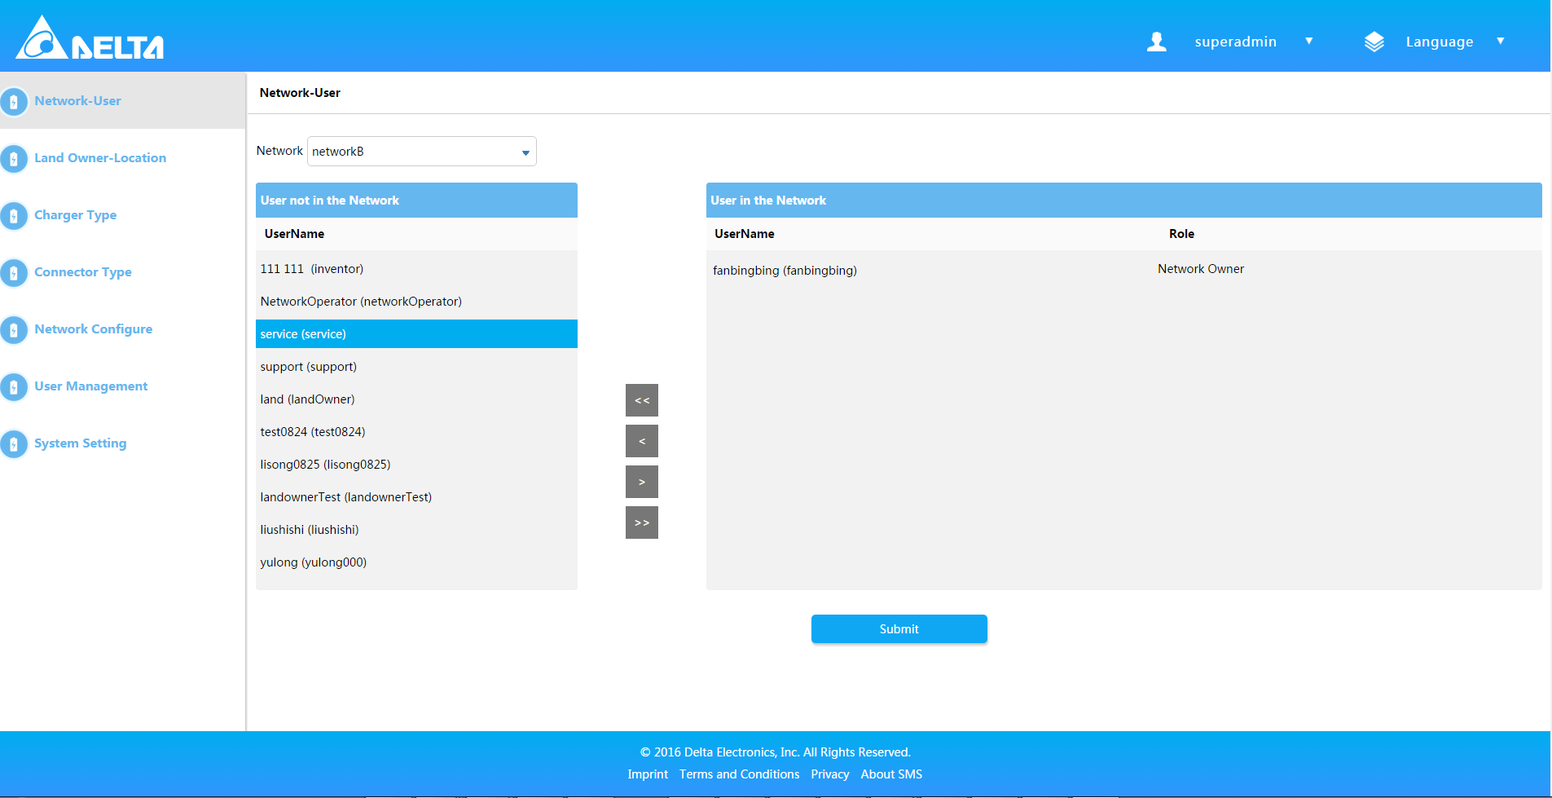

1. Select a role from “User Role” dropdown list, such as “Land Owner” and submit.

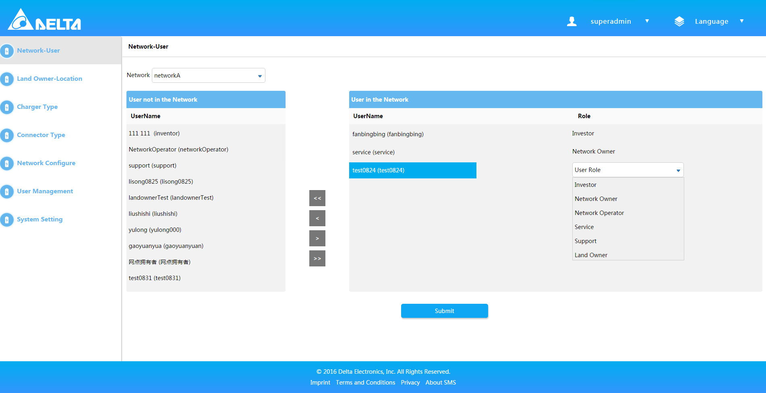

1. There are also ways to add or remove all users from the network via “>>” and “<<” buttons.

## Land Owner-Location

Note: Once distribute network from “Network-User” and assign the role “Land Owner” to the user, then you can operate this item.

1. Navigate to Admin page, there is the option “Land Owner-Location” on the left list.
2. Choose the same network last time you distribute.

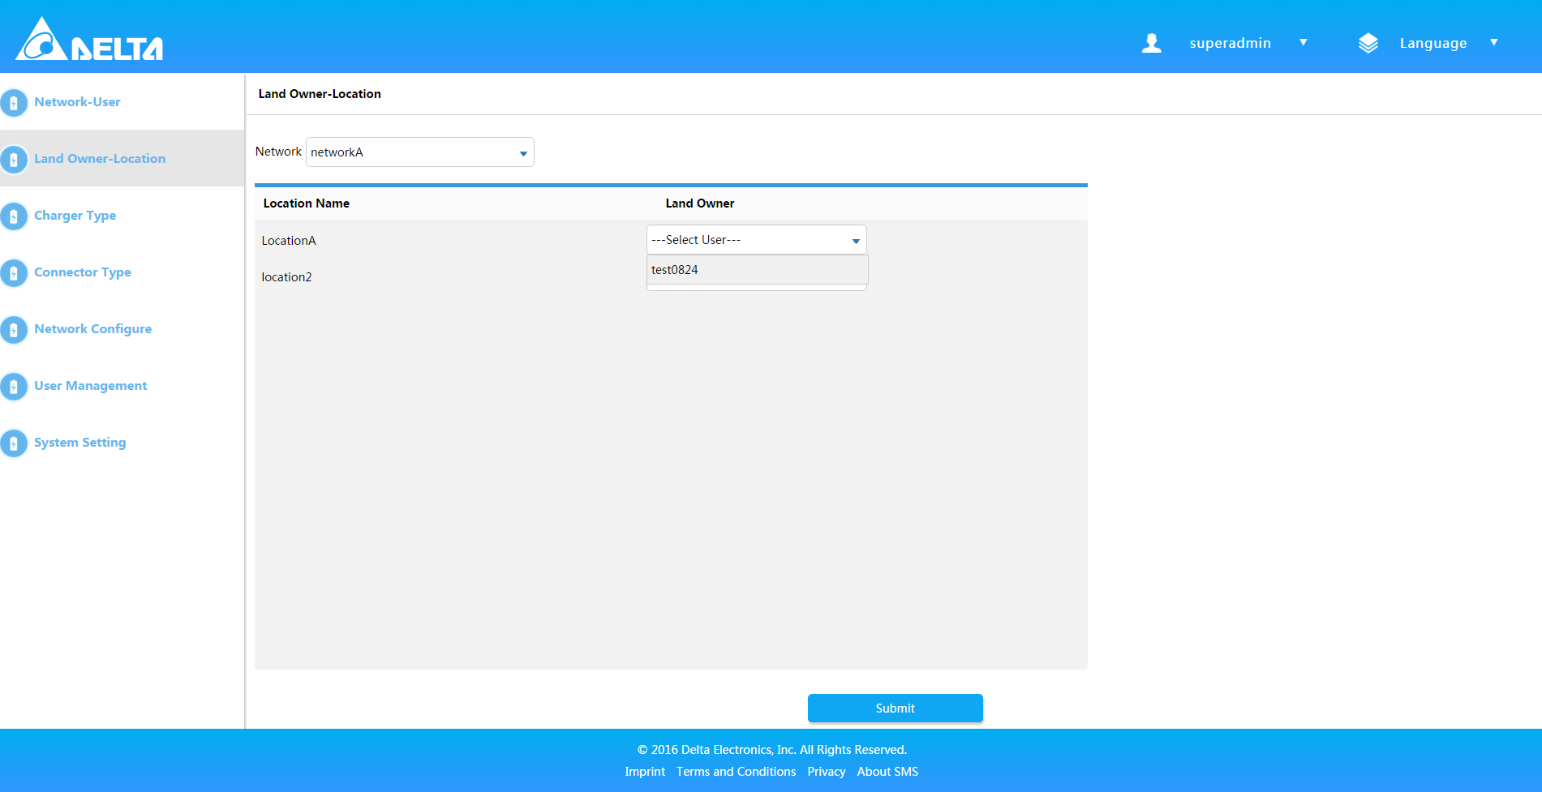

1. Select a user from dropdown list for the location and submit.

# Network

## Overview

1. Login successfully and show the main interface.
2. Choose one of the networks and enter. *Not*e*: User will enter to the overview page if belongs to one Network.*
3. It will show the overview page.

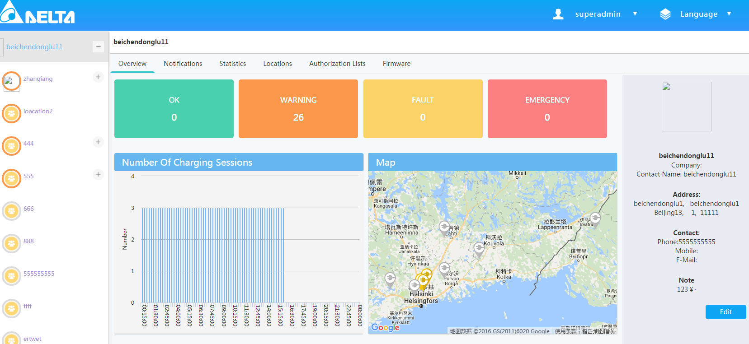

## Location

### Create one Location

1. Login successfully and show the main interface.
2. Choose one of the networks and enter.
3. Find the “Locations” option on the navigation menu and enter.
4. Click “Add Location” then the popup window will show.

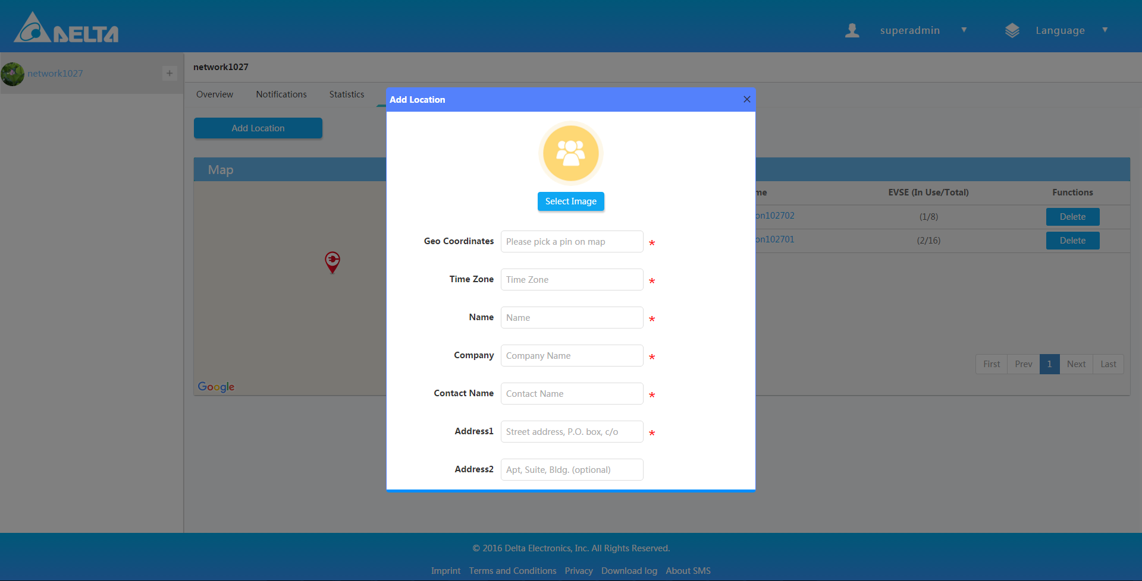

1. Fill up necessary information and click “Submit” to finish the location creation.

### Delete one Location

1. Login successfully and show the main interface.
2. Choose one of the networks and enter.
3. Find the “Locations” option on the navigation menu and enter.
4. Find the “Delete” button, and click to delete the location.

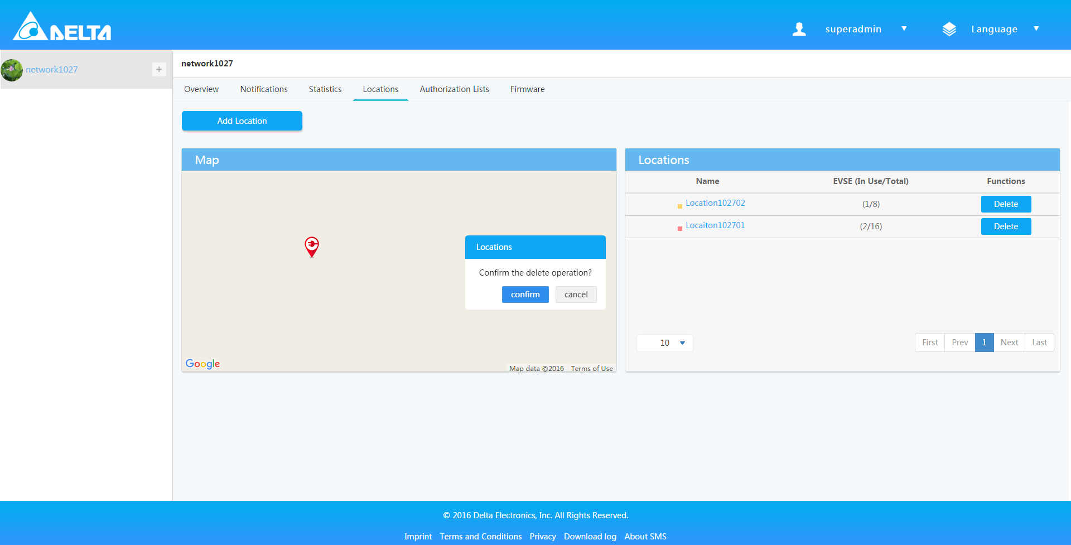

## Authorization list

### Create Authorization list

1. Login successfully and show the main interface.
2. Choose one of the networks and enter.
3. Click the “Authorization Lists”.
4. Click “Create New List” button.

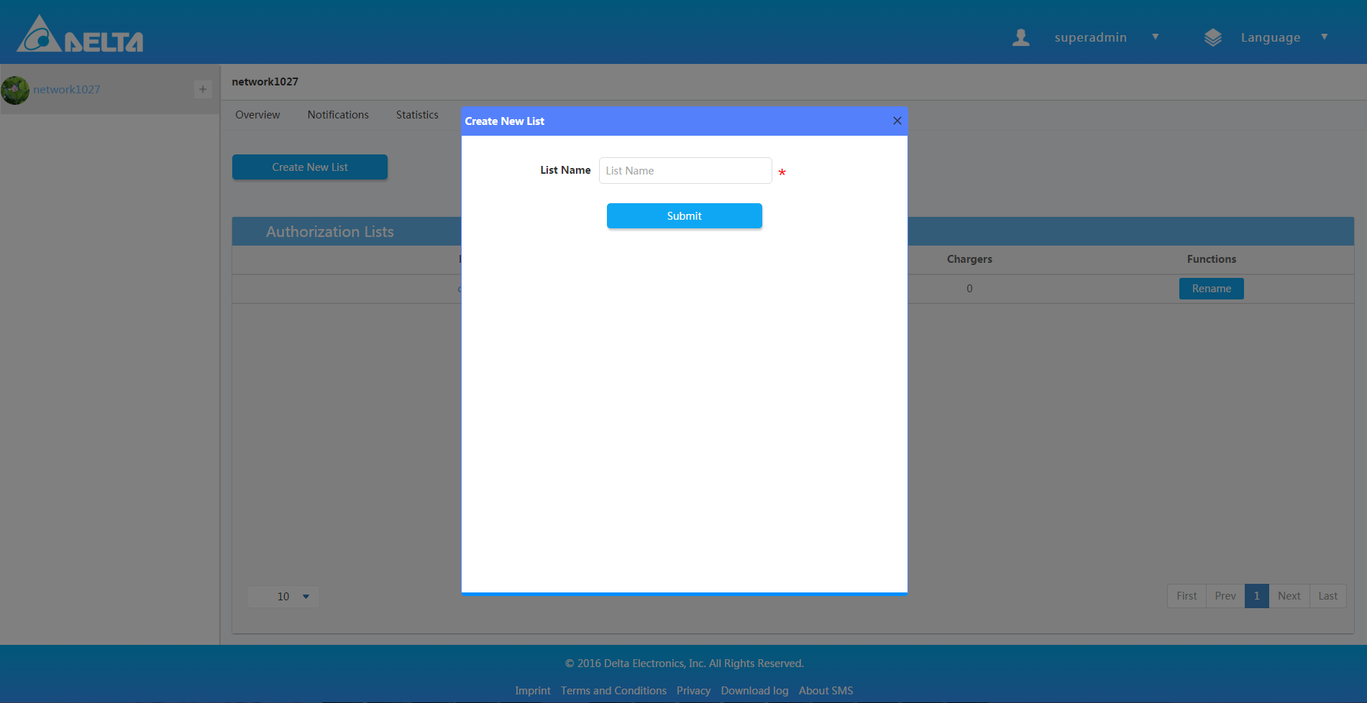

1. Input the list name and submit.

### Add Authorization IDs

1. Login SMS system.
2. Choose one of the networks and enter.
3. Navigate to “Authorization Lists” and choose “Authorization IDs”.
4. Choose the network from dropdown list “Authorization Lists”.

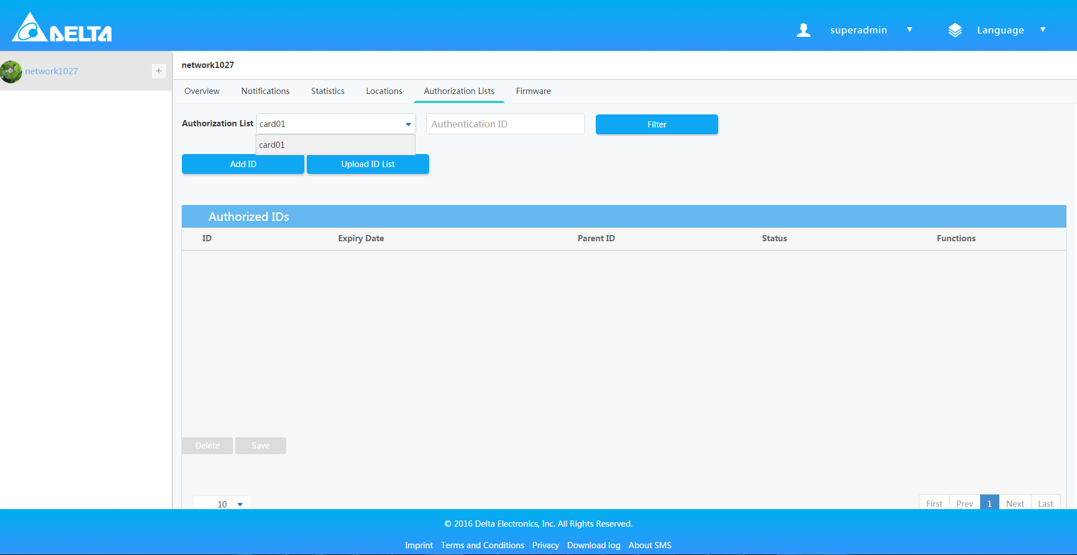

1. Click “Add ID” button and input the ID and Parent ID then click submit.

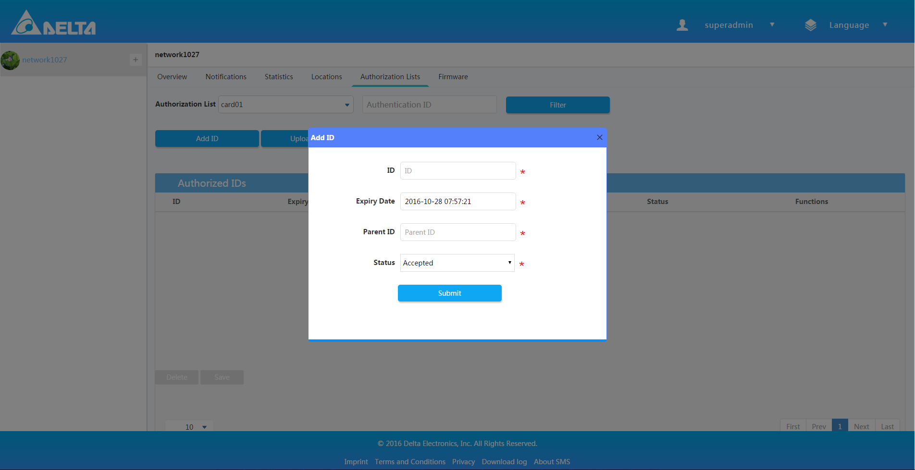

1. Or click “Upload ID List” and upload the “.xls” file for batch IDs adding.

### Add Subscribed Charger

1. Login successfully and show the main interface.
2. Choose one of the networks and enter.
3. Navigate to “Authorization Lists” tab.
4. Choose “Subscribed Charger”.
5. Choose the network which you want in the spinner “Authorization Lists”.

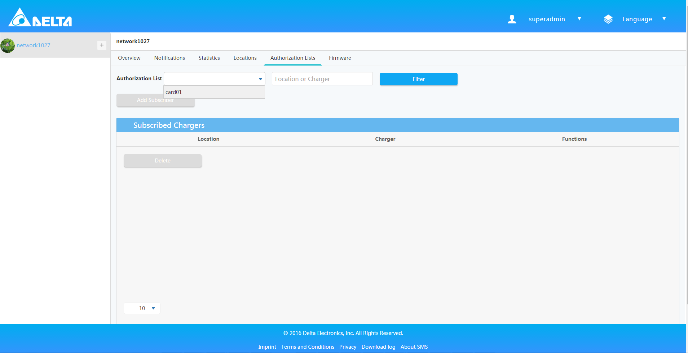

1. Click “Add Subscriber” button then pop window will show.

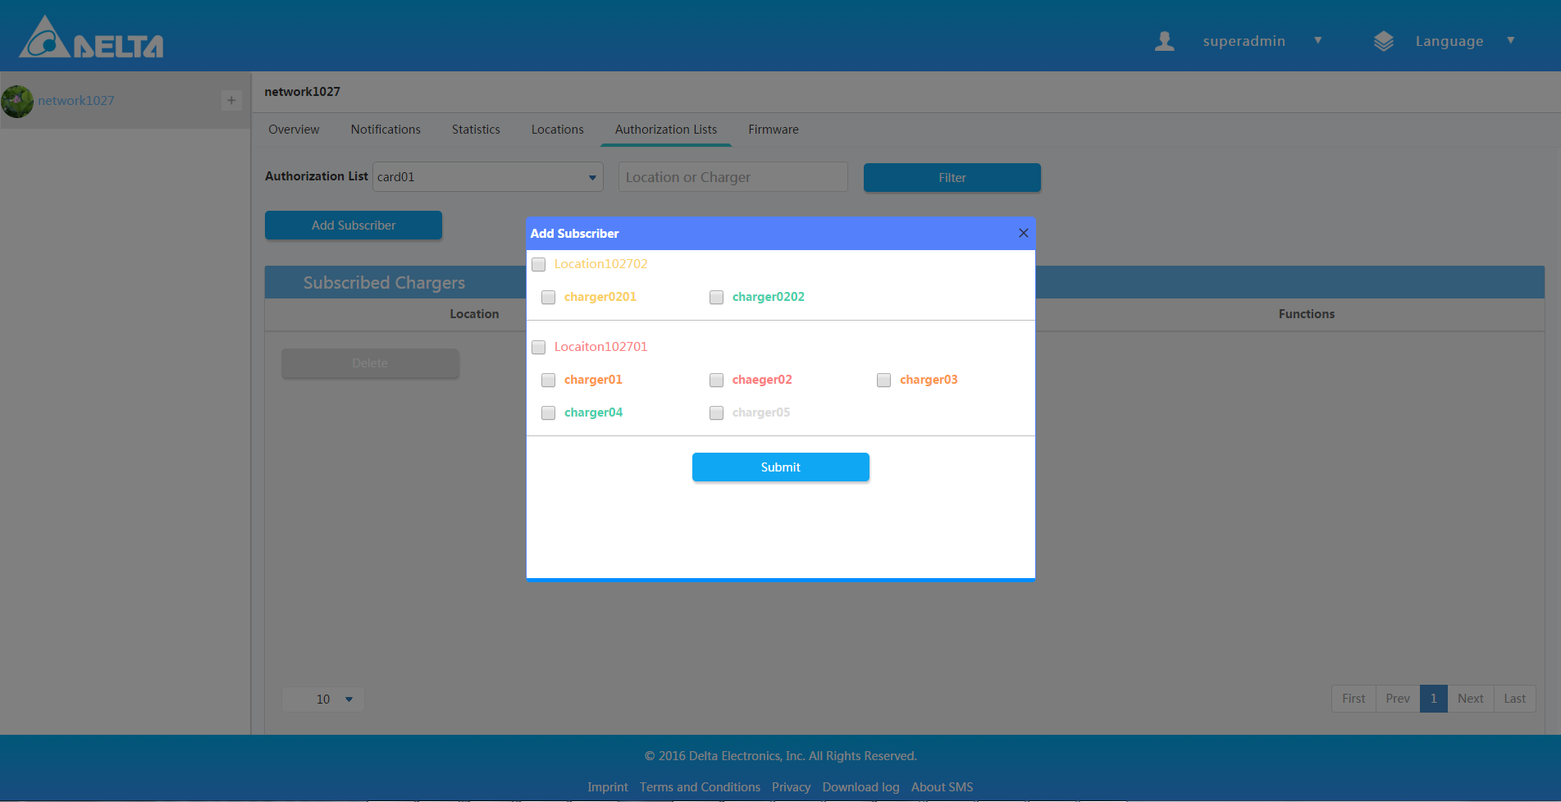

1. Choose all subscribers or only one subscriber just as you want and save.

## Statistic

1. Show the charger’s number, charger’s power, charger’s energy, charger’s energy power KPI.
2. And you can view the statistical data by change the time .

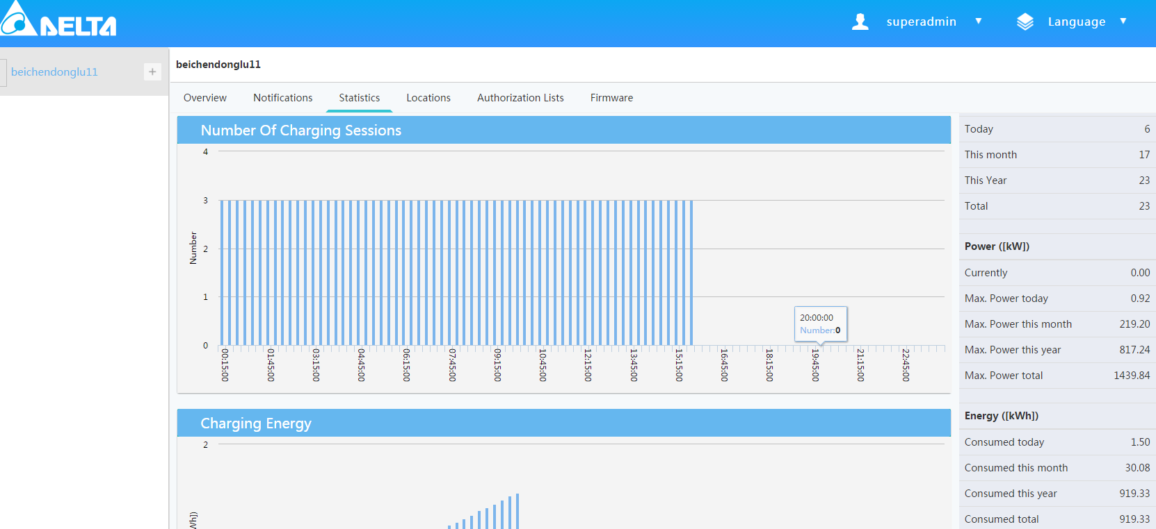

## Firmware

### Add Firmware

1. Login SMS system.
2. Choose one of the networks and enter.
3. Click the “Firmware”.
4. Choose anyone charger type from drop-down list.
5. Click “Add Firmware” button.

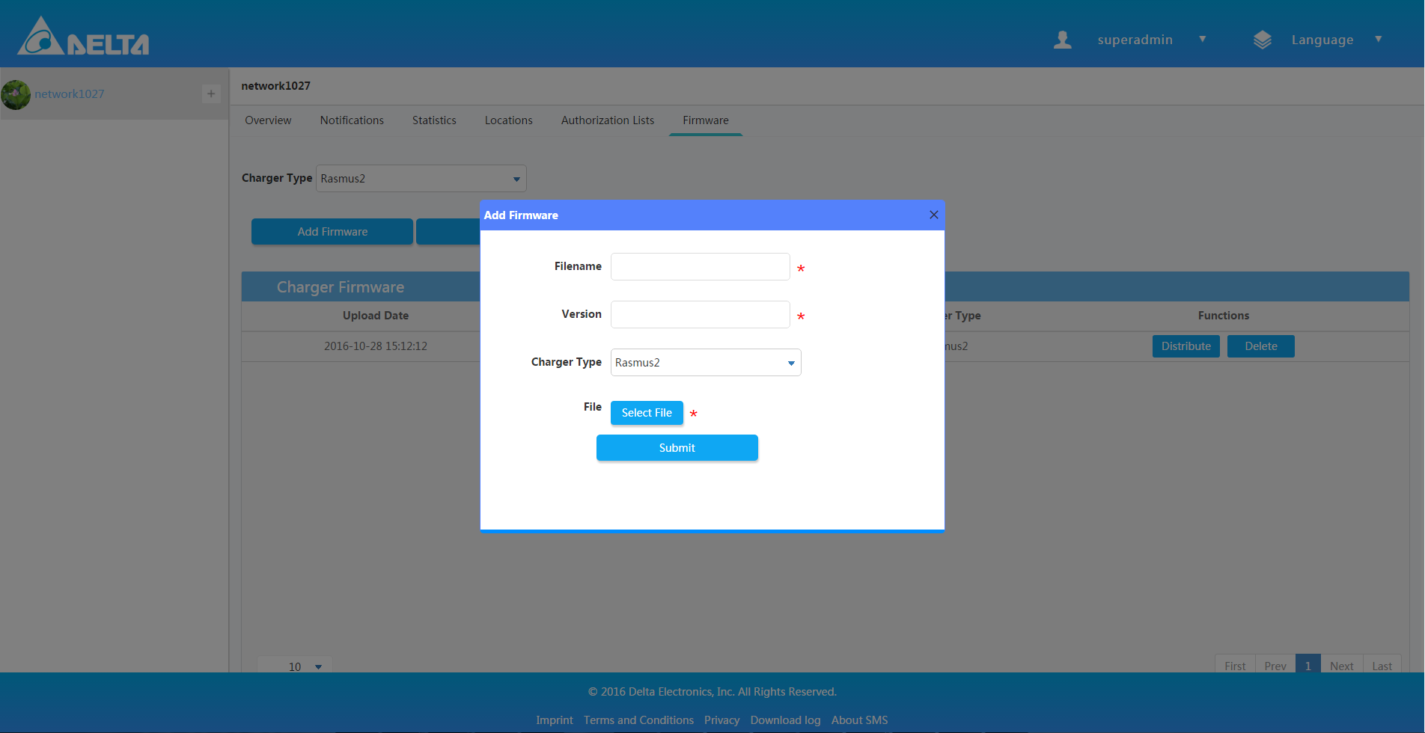

1. Input any words.
2. Click Submit.

### Edit FTP

1. Login SMS system.
2. Choose one of the networks and enter.
3. Click “FTP” button.

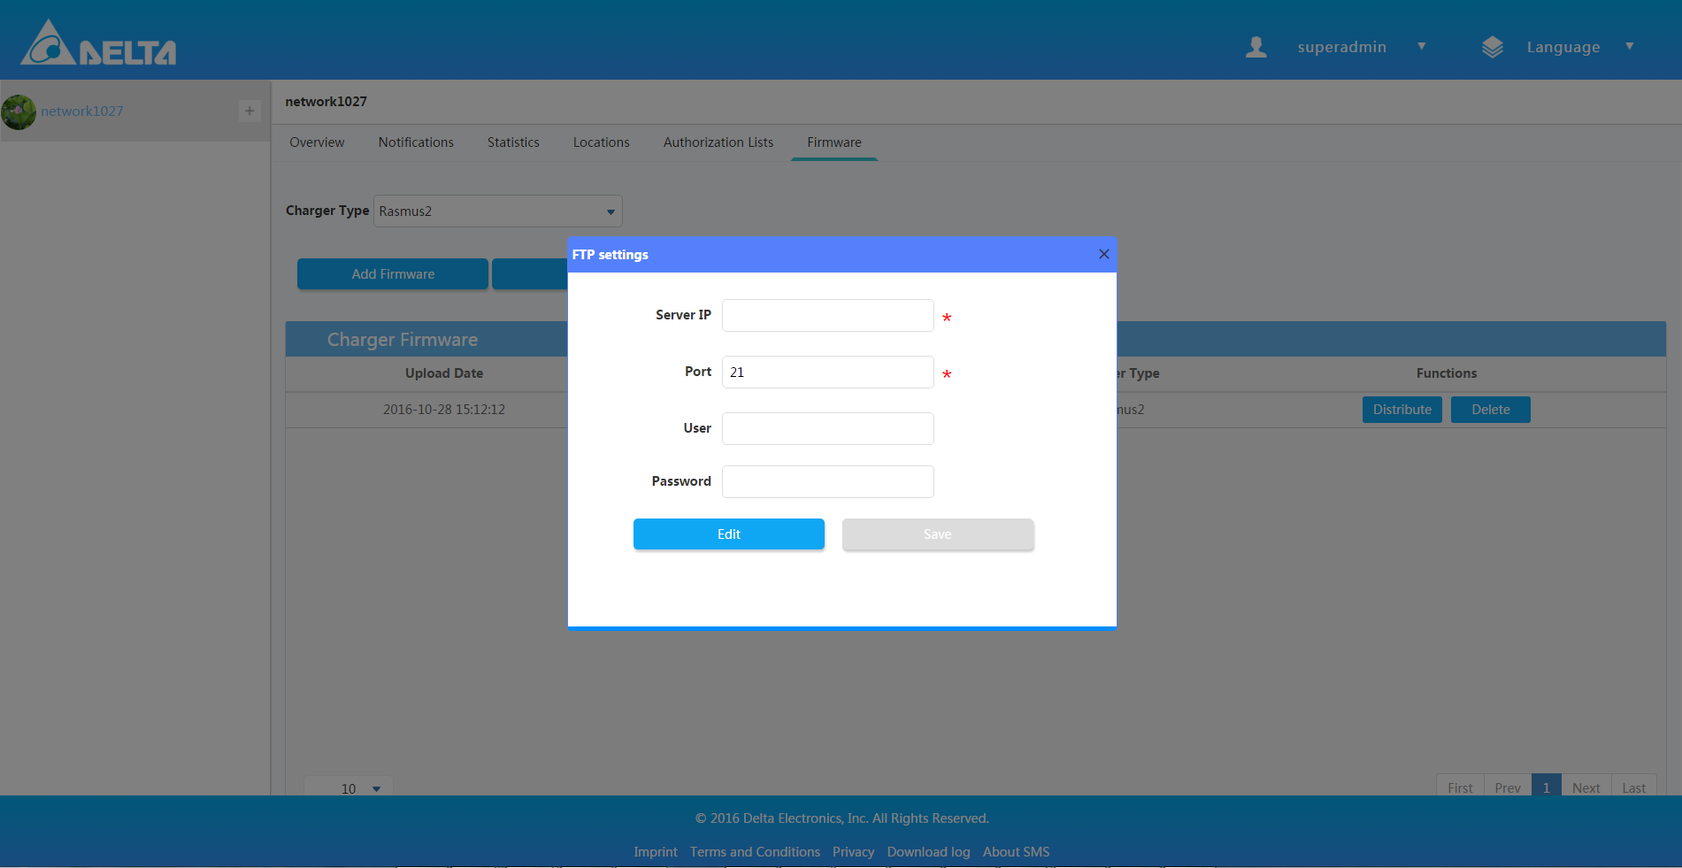

1. Click “Edit” button.

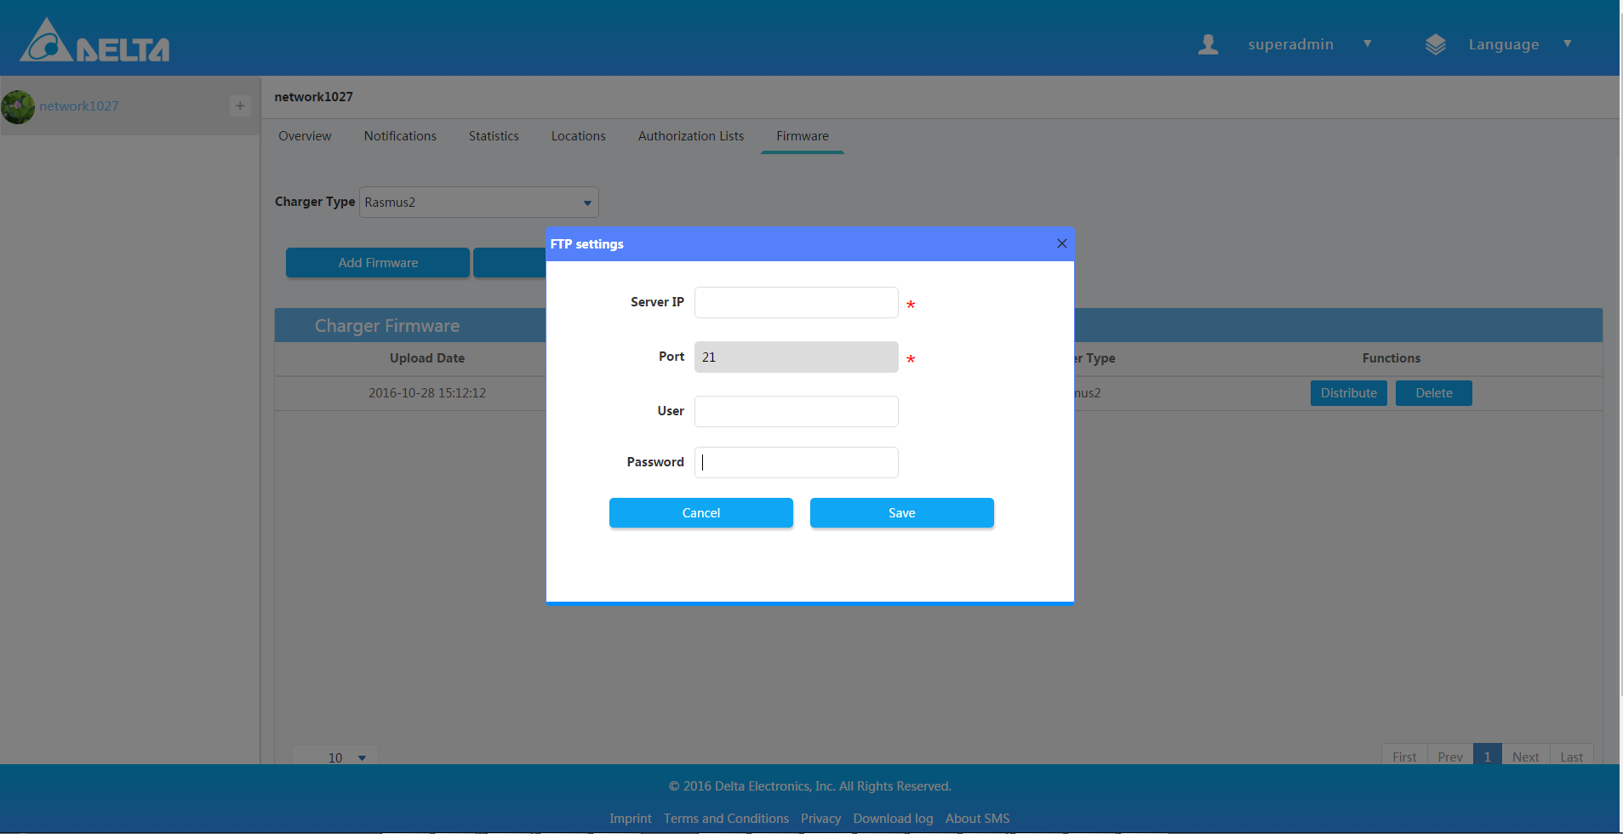

1. Input some words.
2. Click “Save”.

### Delete Firmware

1. Login SMS system.
2. Choose one of the networks and enter.
3. Click the “Firmware” .
4. Click “Delete” button.

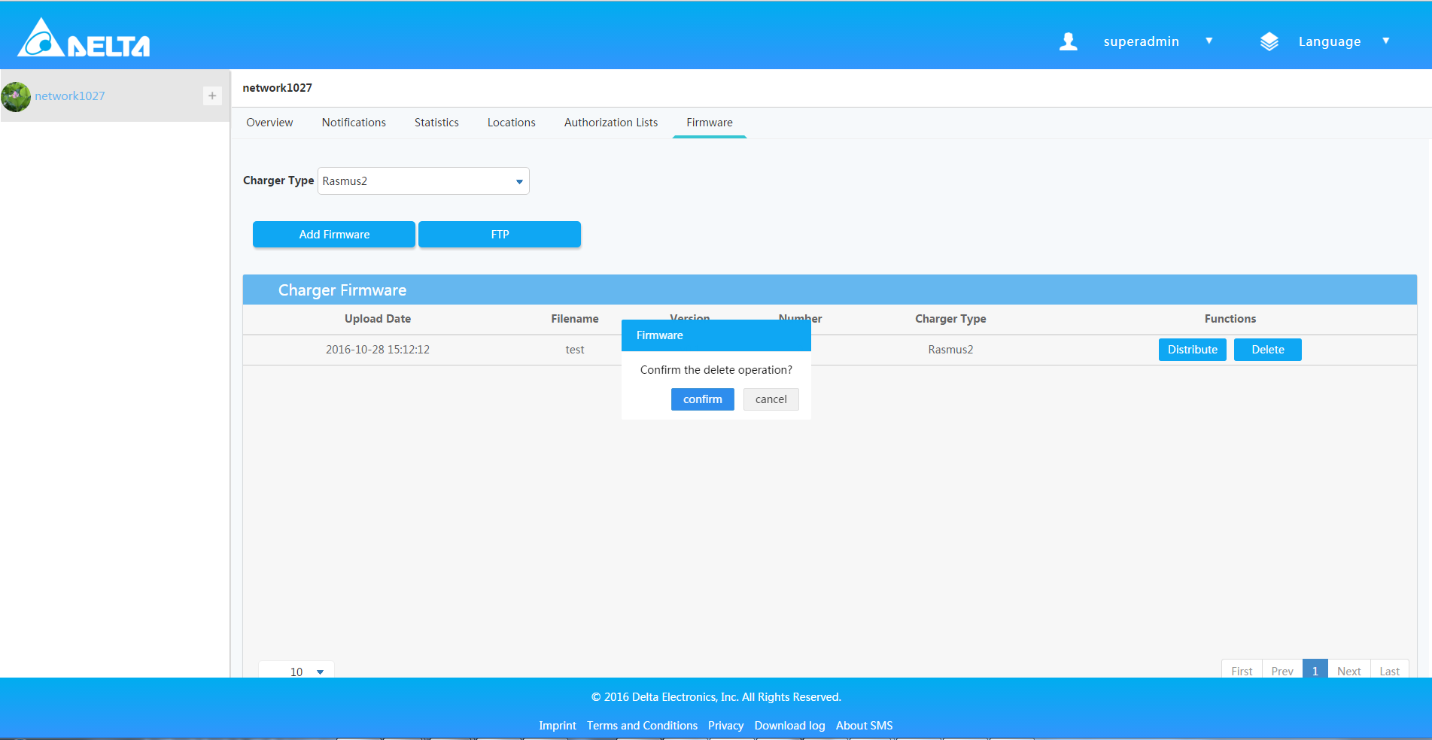

1. Click confirm.

### Distribute Firmware

1. Login SMS system.
2. Choose one of the networks and enter.
3. Click the “Firmware”.
4. Click “Distribute” button.

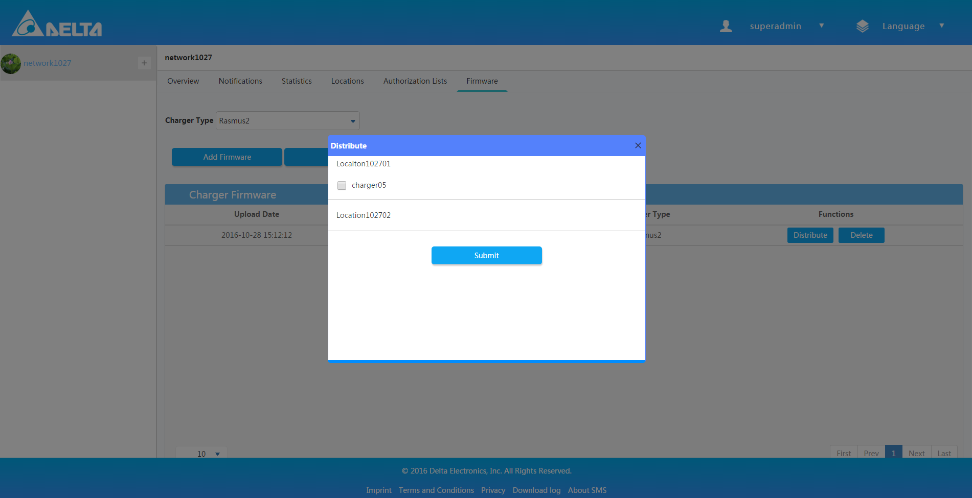

1. Choose any one checkbox.
2. Click confirm.

## Notifications

It shows warning, fault, emergency information about charger and location.

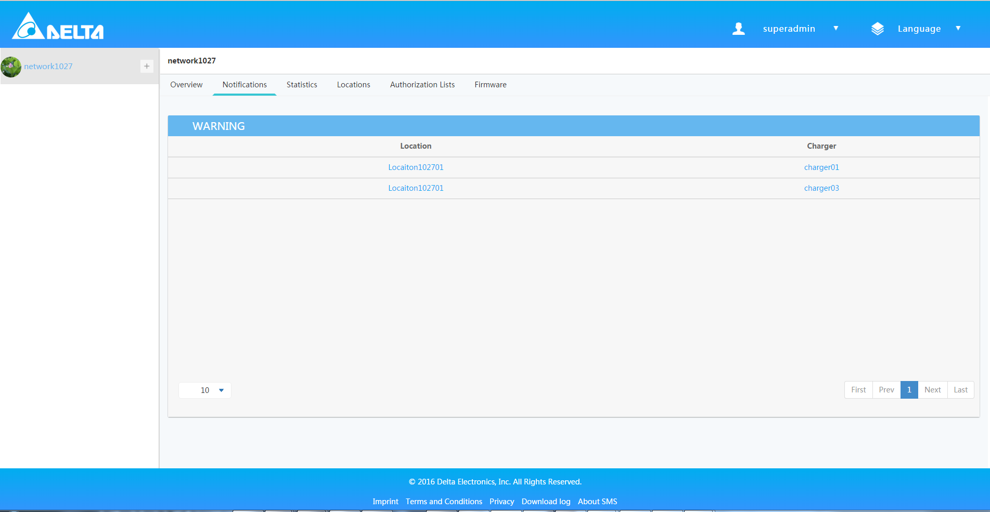

# Location

## Overview

1. Login successfully and show the main interface.
2. Choose one of the networks and enter.
3. Click “+” icon at the tree menu on left side.
4. It’ll show many locations.
5. Entry the first charger and you can view the overview page.

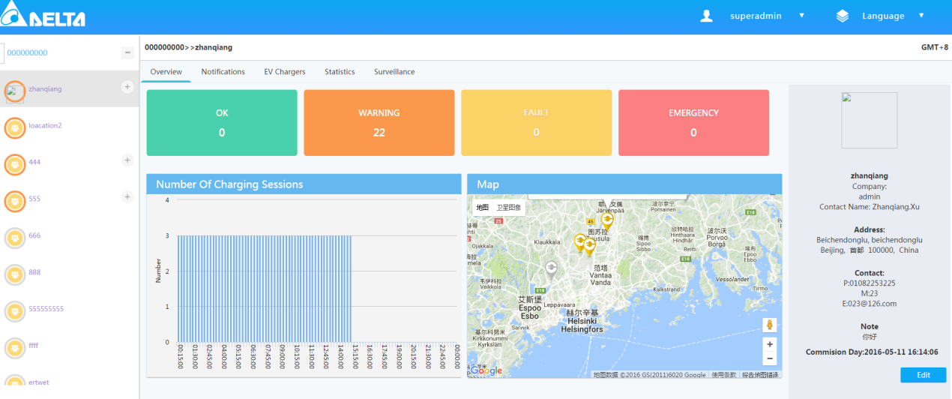

## Statistic

1. Show the charging session number, charging power, charging energy, charging KPI.
2. And you can also view the statistical data by different ranges of time.

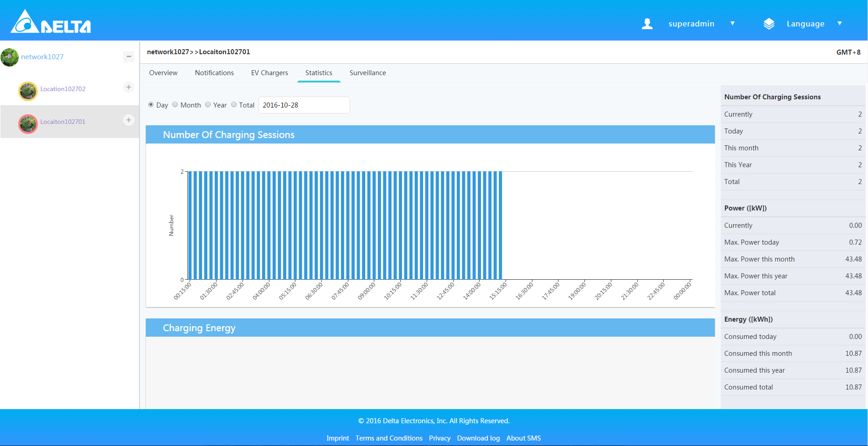

## EV Chargers

### Create one Charger

1. Login successfully and show the main interface.
2. Choose one of the networks and enter.
3. Click “+” icon to spread out locations, then click one Location Name.
4. Navigate to “EV Chargers” tab.
5. Click “Add EV Charger” then the popup window will show.

* Charger Name is the name will display on the web.
* Please contact administrator to add a new charger type, or select one from the from the dropdown list.
* Serial Number is in sting type and has 25 text long limitation.
* For EVSE, you have to choose the right type from dropdown list.

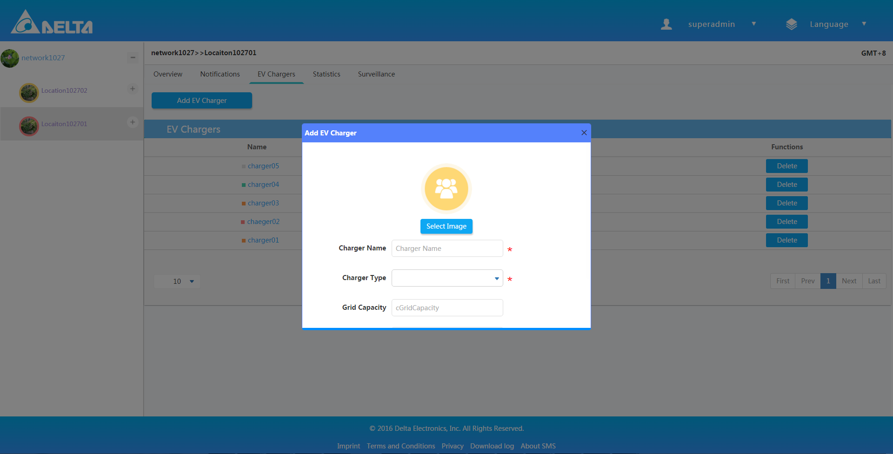

1. Click “Submit” to finish the creation.

### Delete Charger

1. Once login successfully and show the main interface.
2. Choose one of the networks and enter.
3. Click the “+” icon at the tree menu on left side, it will show many locations.
4. Click the first location, you’ll find “EV Chargers” and click it.
5. Click “Delete” button, you’ll delete one charger.

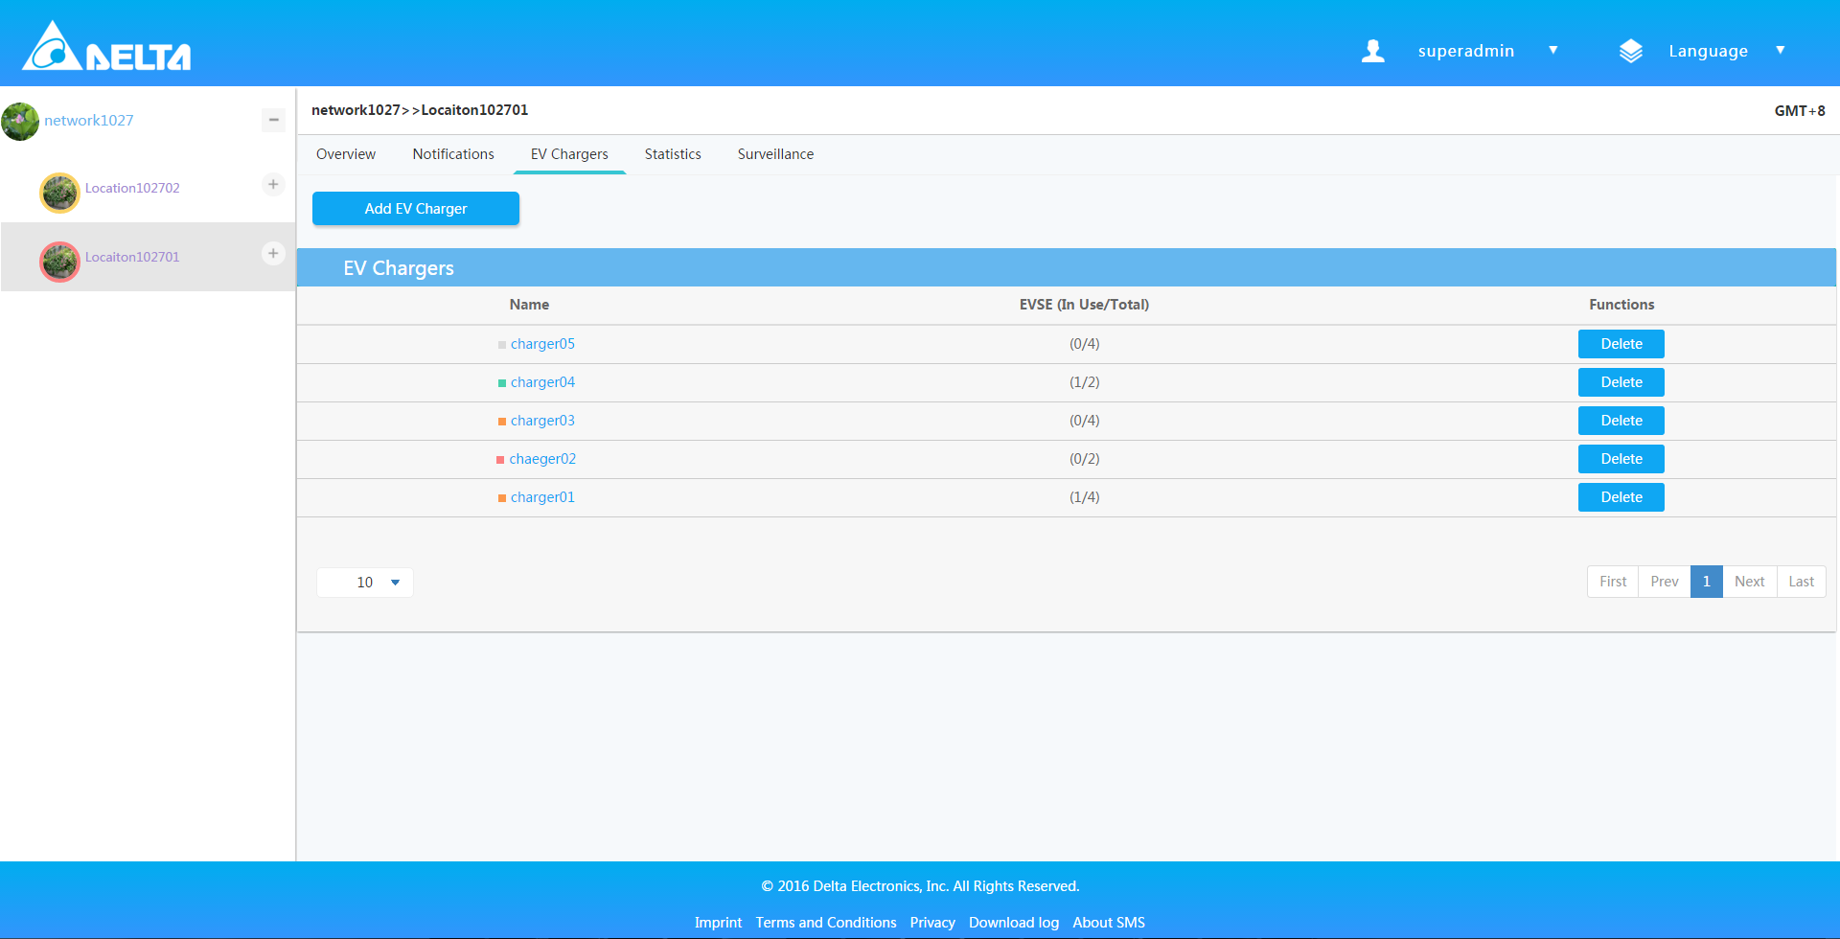

## Notifications

It shows warning, fault, emergency information about charger and location.

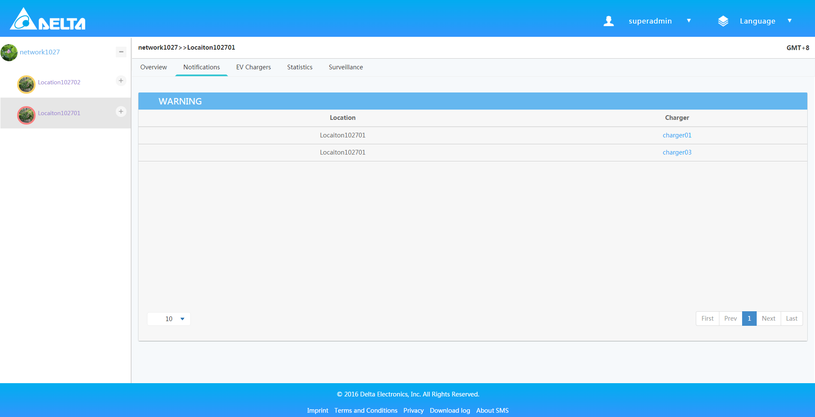

# Charger

## Overview

1. Login successfully and show the main interface.
2. Choose one of the networks and enter.
3. Click “+” icon in the tail of Network Name to spread out locations.
4. Click “+” icon in the tail of Location Name to spread out chargers.
5. Choose one of chargers and the overview page will show.
6. The overview contains charger information, EVSEs type, statistics data and so on.

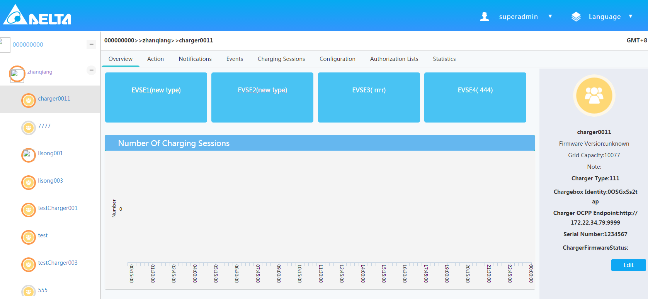

## Action

1. Login successfully and show the main interface.
2. Choose one of the networks and enter.
3. Click “+” icon in the tail of Network Name to spread out locations.
4. Click “+” icon in the tail of Location Name to spread out chargers.
5. Navigate to “Action” tab.
6. The tab offers functions to control the charger including restart, reboot, clear cache, update whitelist, start/stop transaction and even release connector.

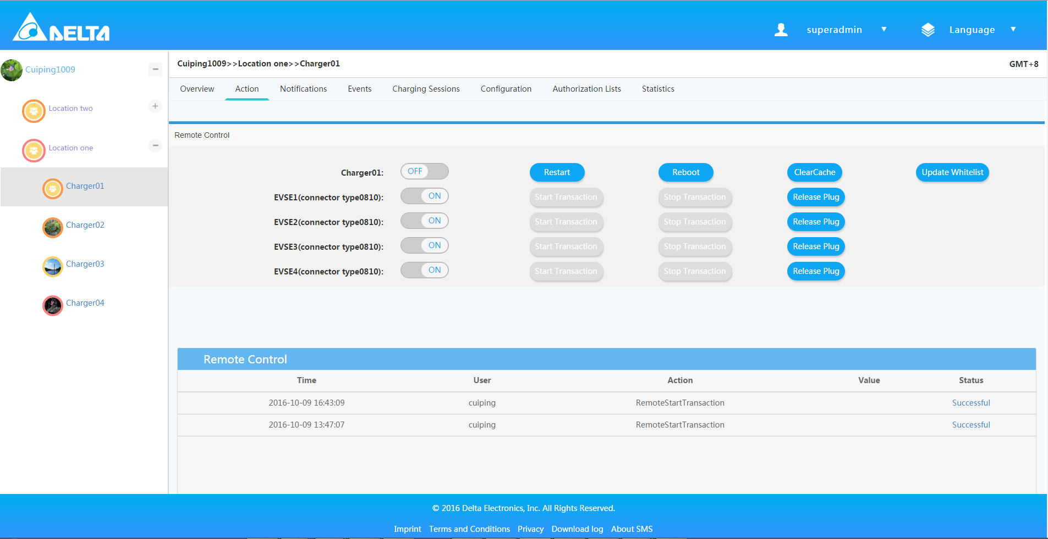

## Notification

1. Login successfully and show the main interface.
2. Choose one of the networks and enter.
3. Click “+” icon in the tail of Network Name to spread out locations.
4. Click “+” icon in the tail of Location Name to spread out chargers.
5. Navigate to “Notification” tab.
6. At this page, you can view the warning, fault, emergency information of chargers.

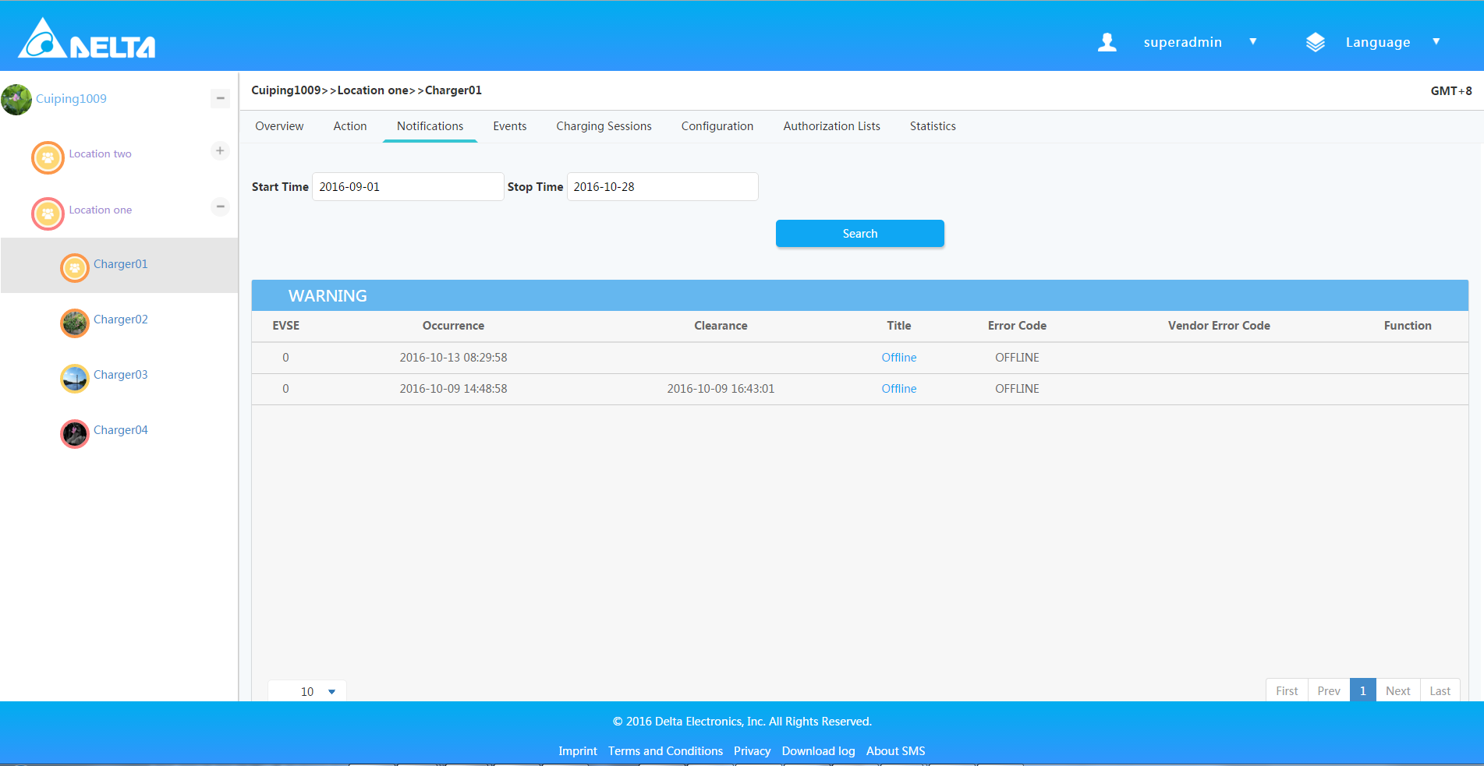

## Event

1. Login successfully and show the main interface.
2. Choose one of the networks and enter.
3. Click “+” icon in the tail of Network Name to spread out locations.
4. Click “+” icon in the tail of Location Name to spread out chargers.
5. Navigate to “Event” tab.
6. At this page, you can view logs about charger.
7. And it’ll show the event result by level, by title, by time.

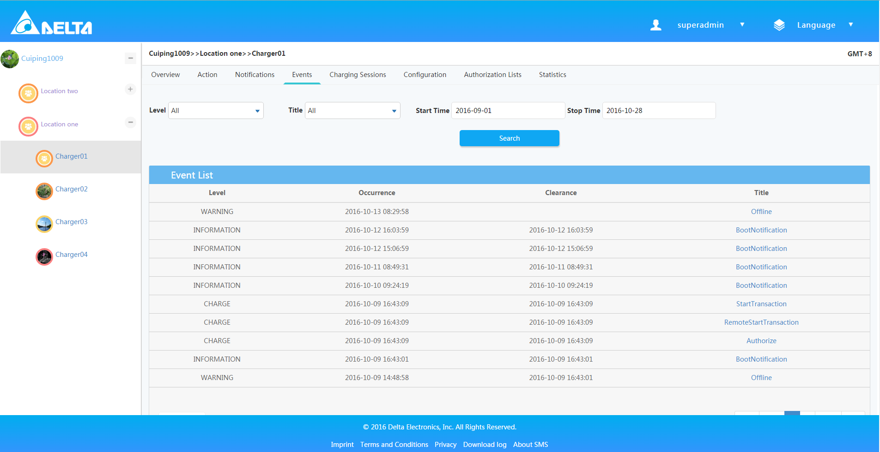

1. At the same time, you can also eliminate the problem of Firmware events.

## Charging Sessions

View the charger recording information and search the information by timing order.

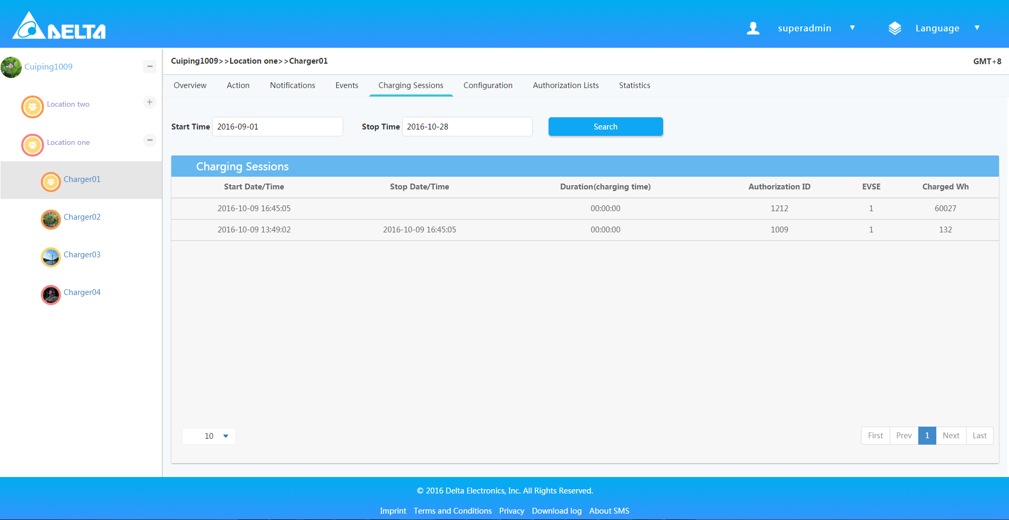

## Configuration

The tab offers read or write configuration to the charger.

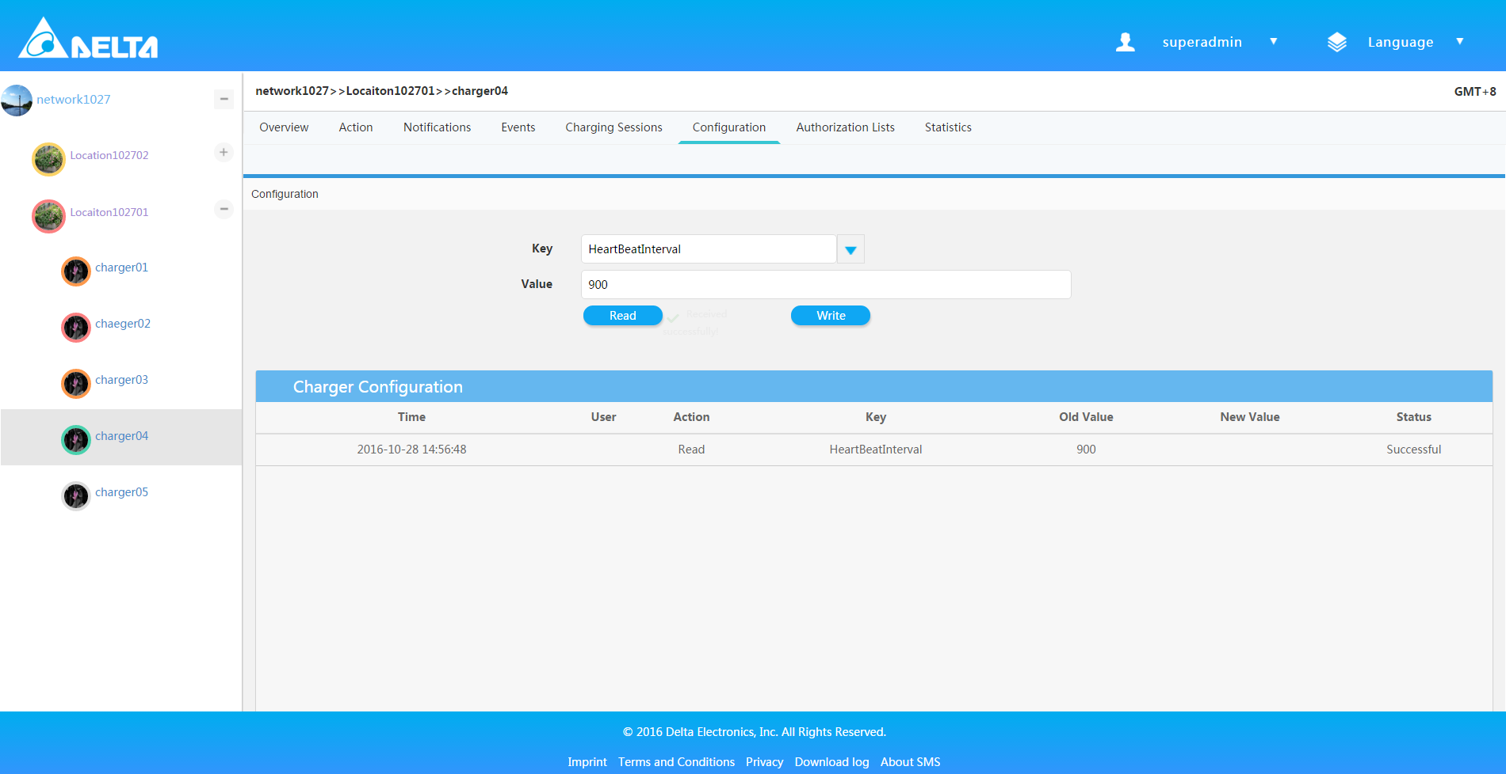

## Authorization lists

1. Subscribe new list by “Subscribe New List” button.
2. From “Download Compile List” button, you can download it.
3. And you can click “Delete” to unsubscribe the list.

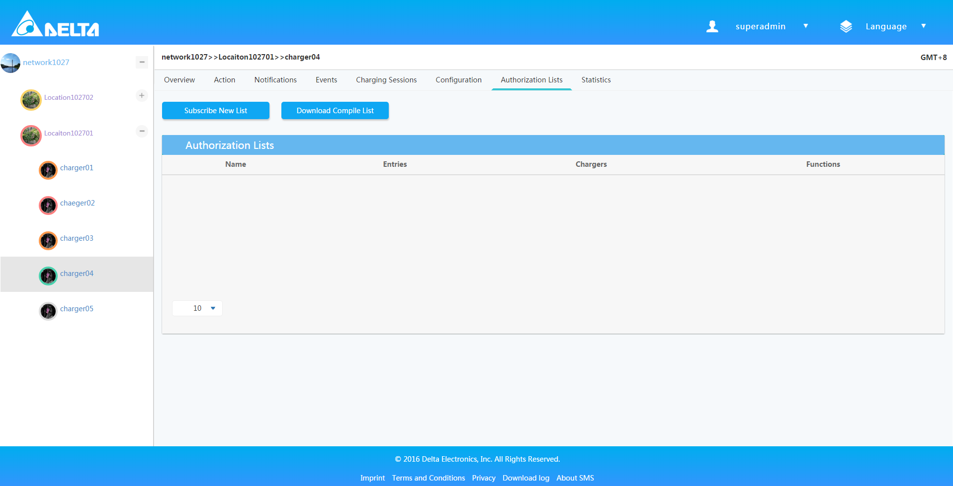

## Statistic

1. Show the charging session number, charging power, charging energy, charging KPI.
2. And you can also view the statistical data by different ranges of time.

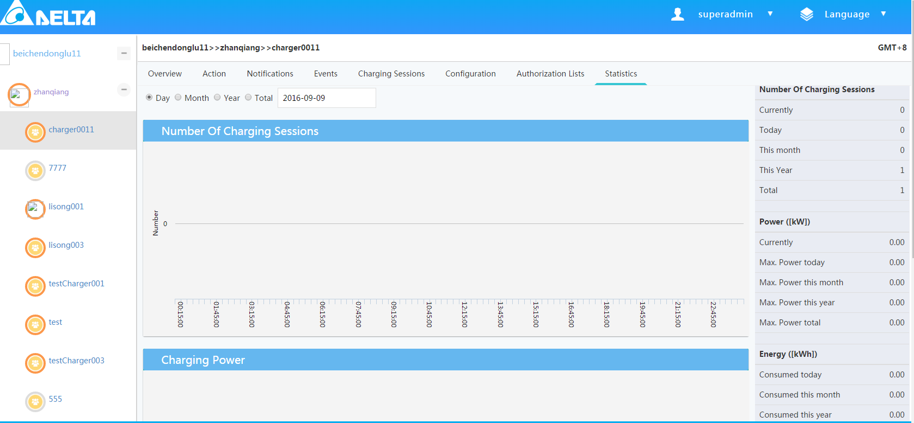

## Connect to the Charger

1. Click the charger in tree menu on left side, or click the charger name in the charger list under the location page.
2. There is Chargebox Identity information on the right-down corner.
3. Copy the id and paste to the charger settings.
4. Enter <http://172.22.35.131:8089/CentralSystemService15> for the Central System Endpoint.
5. Once reboot the charger, it will automatically connect to the SMS, and the status color will change to green. Refresh the page will see detail information update on the right side.

# Download log

1. Login successfully and show the main interface
2. Choose one of the networks and enter.
3. And you can Click “Down Log” button at the bottom on the page
4. At this page, you can view the files log of chargers
5. Choose one file and click “download” button

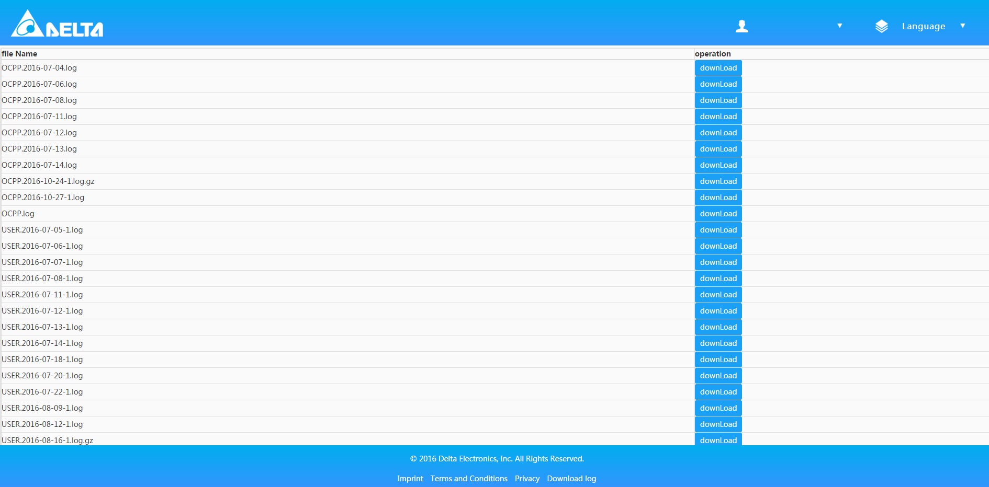

# Version

1. Login successfully and show the main interface
2. Click “About SMS” button to view the system version number

